E-SERVICE

Vol. 9, No. 24 SALESIANS OF DON BOSCO - NEW ROCHELLE, NY Dec. 15, 2011

Message from Fr. Provincial

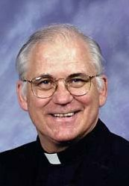

Advent Season
During this time of the year we are immersed in the words of St. John the Baptist: “Prepare the way of the Lord.” Undoubtedly, much of our time and effort during Advent time is spent preparing for a wide variety of things. We spend a lot of time preparing for the cultural celebration of Christmas. We send out greeting cards, decorate our houses, purchase gifts, plan community meals and celebrations, and reach out to family and loved ones.

Only an incurable Grinch would argue against these cultural traditions in our lives as individuals, communities, and society. Historically, these cultural symbols are rooted in Christian values and doctrine. To be true to our identity as disciples of Christ, we have to make these Christmas symbols express our faith in God’s promise to “give his only begotten Son that whoever believes in him shall not perish but have eternal life” (John 3.16).

Following our call to proclaim the Gospel, we make our Christmas preparations effective means of inserting the message of Christ’s birth and second coming into our immediate surroundings and the culture of our people. In every aspect of our Advent lives we proclaim: “Come, Lord Jesus.”

During this liturgical time we assume the attitude of expectant waiting. Our reflections on the prophets nourish our spiritual lives by the promise of a Savior to the people of Israel.

Our journey through Advent reminds us of the promise of the Lord to return again in glory. The way we celebrate Advent helps us to celebrate Christ’s birth in Bethlehem and to look forward to his second coming at the end of time. As we call out “Maranatha,” we wait with joyful expectation.

Waiting
It might be helpful for us to reflect a bit deeper on the nature of this Advent waiting. In my own life I can distinguish between three types of waiting: passing the time; anticipating; preparing. If you do any amount of traveling, you are very familiar with the first form of waiting (passing the time). Sitting in an airport waiting area until boarding is a mind-numbing experience. It is great for daydreaming, people watching, and speculating on whether the flight will be on time or not. In this form of waiting, we are passive, totally dependent on the action of others. This waiting consists in enduring the passage of time without any active engagement on our part.

A second type of waiting (anticipating) brings forth from within us a sense of joy and expectation. While waiting for the arrival of a family member or a good friend, we are filled with an anticipated sense of exhilaration. We feel excitement in anticipating the first glimpse of and greetings shared with our loved one.

The third type of waiting (preparation) demands our full engagement in accom-modating ourselves to a new arrival or situation. When we invite loved ones to join us for a holiday dinner, we make extra efforts to be sure that these people feel at home, are taken care of, experi-ence the loving attention they deserve. We adapt our lives so that our guests will feel as if our house is their house. This level of waiting demands that we change our normal patterns of life for the sake of another. It entails elements of conver-sion, service, and communion.

My sense is that for the Advent season to fulfill its purposes in our lives, we will have to wait with an attitude of active preparation. “Prepare the way of the Lord” calls us to the inner conversions

and the external transformations that will align us to the presence of Christ in our present lives and to help further God’s kingdom in the world. The words of St. John the Baptist can be helpful in orienting us to this more effective celebration of the Advent season.

Repent and believe the good news (Mark 1. 15).
Preparing for Christ’s coming demands that we embrace the radical change that God has offered us in the incarnation of his Son, Jesus Christ. We believe the implications of this good news in our lives. We cast aside the sinful ways of living that are not rooted in Christ’s teaching and example.

He must increase and I must decrease (John 3. 30).
Our Advent reflections have to be centered on the person, words, and actions of our Lord Jesus Christ. As with John, we are called to die to self during this season so that Christ the way, the truth, and the life will be more fully integrated into our very person as consecrated religious.

The time has come. The King-dom of God is near (Mark 1.15).
Our Advent practice cannot be limited to our own lives or that of our immediate surroundings. The Lord has come to initiate God’s kingdom of justice, peace, and love. Our call in Advent is to take practical steps to further that kingdom throughout the world, especially with those who are most deprived of what is due to them by virtue of their dignity as human persons and God’s children.

This week we begin the Christmas novena. Let us take care to make this beautiful practice more than a heart-warming moment of nostalgia. May the recurring theme of this novena be true in our lives: “The Lord our King is drawing near! O come! Let us adore him.”



Vol. 9, No. 24 – 2 of 4 E-SERVICE December 15, 2011

Schedule of the Provincial

December
16 Office Day
17 Postnovitiate Curatorium Meeting, Orange, N.J.
18-23 Office Days
24-25 Personal Days

Pray for Our Sick

Bro. Gerald Warner, SDB
Hospitalized with a stroke

Fr. Edward Cappelletti, SDB
Fr. Frank Wolfram, SDB
Fr. Bernie Gilliece, SDB
Maria Theresa Rien T. Mai
Mother of Fr. Dominic Tran, SDB

Pray for Our Deceased

Daniel Neves
Brother of Sr. Phyllis Neves, FMA

Coming Birthdays

December
17 Fr. Stephen Ryan
18 Fr. Mark Hyde
18 Br. Donald Caldwell
22 Fr. Michael Mendl
23 Fr. Harry Peterson
25 Br. Gerald Warner
26 Fr. John Basso
27 Br. Joseph Ackroyd
28 Fr. Mario Villaraza

Provincial Announcement

The Salesian Education Symposium scheduled for January 13 at Don Bosco Prep, Ramsey, has been cancelled.

E-Service
148 Main Street
New Rochelle, NY 10802-0639
E-Mail: servicesue@aol.com
Phone: (914) 636-4225

E-SERVICE Newsletter
Published Weekly by the Salesians of
St. John Bosco for the confreres of the
Province of St. Philip the Apostle,
New Rochelle, N.Y.
Very Rev. Thomas Dunne, SDB, Provincial

Fr. Diego’s Boys Attend Annual Mass

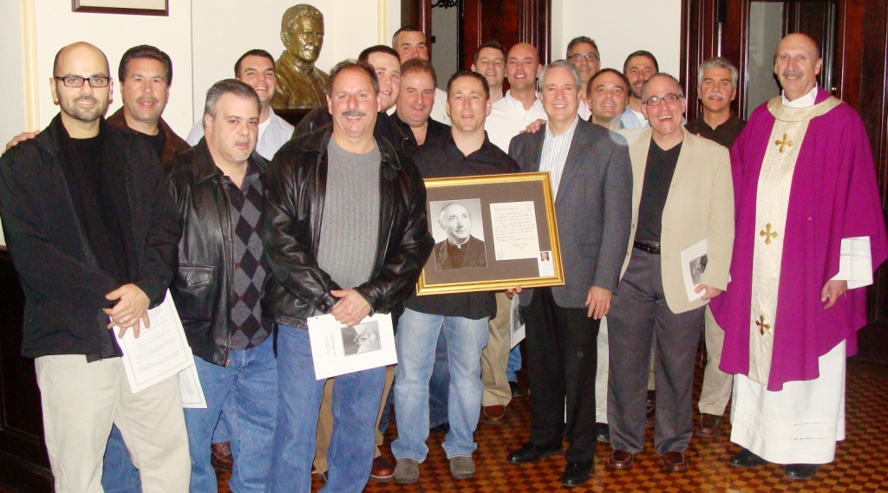

NEW ROCHELLE, New York: On December 9, for the 16th consecutive year, a group of men known proudly as "Diego's Boys" gathered at the provincial house in New Rochelle for a Mass in memory of Fr. Diego Borgatello. This year was somewhat special, as the centennial year of Fr. Borgatello's birth. He died in 1994. Although the English-speaking Salesian world may know him as the translator and editor of vols. 1-16 of the Biographical Memoirs of St. John Bosco, for many dozens of boys and young men in New Rochelle through the 1960s, 1970s, and 1980s he was the leader of their own little oratory, their friend, and their counselor. Thus since his death as many as can come together, gather at the provincial house to recall him and the seeds of faith and goodness that he sowed in their hearts and nurtured by his fatherly attention.

Cooperators Show Appreciation to SDBs and FMAs

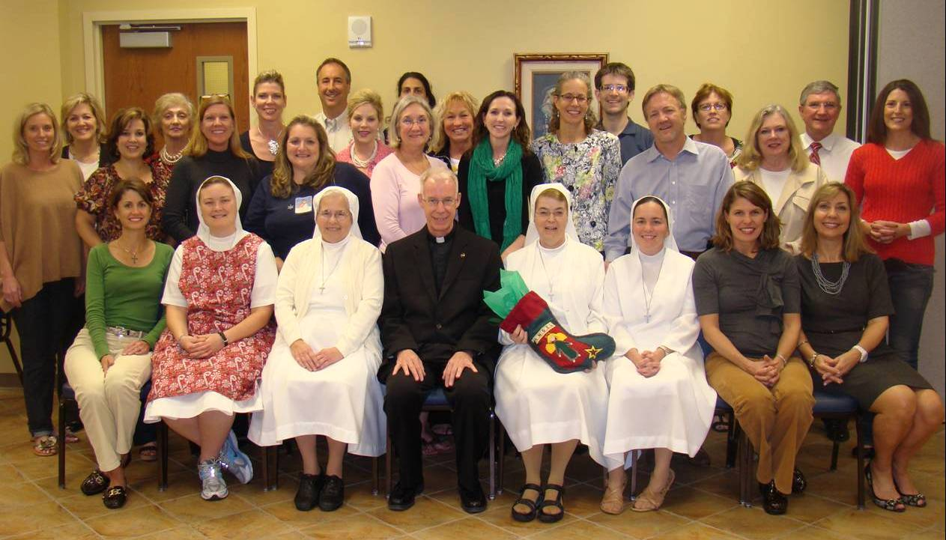

TAMPA, Florida – On December 14 the Salesian Cooperators of Christ the King School hosted a Christmas party to show their appreciation for the support of the Salesians and Salesian Sisters of Tampa. They presented a check for over $2,000 to the sisters for their support of the faculty at the parish school. Fr. Dennis Donovan (center, front) is the SDB province delegate and Sr. Helene Godin (holding the Christmas stocking on her lap) is the local coordinator of the Cooperators at Christ the King The Salesians assist with Masses and confessions at the school and for parish events.

Vol. 9, No. 24 – 3 of 4 E-SERVICE December 15, 2011

Provincial Council Meetings
December 12-14
Fr. Frank Wolfram, SDB

On December 12 our council met for its bi-annual meeting with the sisters’ council of the Haledon Province. They joined us for Mass and breakfast. The meeting was held at the Salesian Missions conference room and went from 9:00-11:55 a.m. After lunch it resumed at 1:00 p.m. to 2:30. Special concern centered on our collaboration in ministries and in new projects (e.g. Bicentennial Committee, Salesian Bulletin USA, Gospel Roads). It also dealt with practical issues affecting our provinces, including summer camps. The January 2012 Salesian Education Symposium was cancelled; we need to find a more effective format. The two councils meet next at Haledon on April 16, 2012.

Our council began its own meetings at 3:00 p.m.
Information shared:
- Fr. Dunne’s visits to Tampa, St. Petersburg and East Boston;
- Fr. Ryan’s youth ministry visits to Montreal and Toronto;
- results of the youth ministry team meeting held on December 10;
- Presidium review board meeting held on December 10;
- fall assessment of our novices;
- evaluation of the practical training workshop;
- monthly financial report and property update;
- department updates;
- legal issues and personnel.
Consultations concerning:
- post-novitiate curatorium meeting for December 17;
- make-up of the provincial council (provincial will choose the model he feels will be most useful to him);
- possible chaplains for GR 2012;
- input for spring leadership meeting and Province Day (March 22-24);
- quick look at some assignments for 2012-2013.
The Salesian Mission Office (Fr. Hyde and Letti Dowell) presented its FY 2012 budget and financial issues.
Decision: budget approved with proviso that it be re-examined in Feb.

There was adequate time for sharing by each councilor of his responses to Fr. Ortiz’ questions for the extra-ordinary visitation dossier report. ■

PYMT Meeting
Fr. Steve Ryan, SDB

On Saturday, December 10, the Province Youth Ministry Team had its quarterly meeting. Present were: Andrea Zimmerman, Bro. Sal Sammarco, Fr. Dominic Tran, Nick Magrogan, Meg Fraino, Adam Rudin, Fr. Jay Horan, Rudy Gomez, Mary Elise Zellmer, Sr. Mary Jackson and Fr. Steve Ryan. Agenda items included the province team members doing the “Rethinking Youth Ministry Reflection” Chapter 1. We had an insightful dialogue on youth culture and evangelization.

I gave an update on visits to the ministries and youth ministry happenings in the province. Fr. Jay Horan led us a little further along on the situation of service and justice education in the schools. The focus was to gain more information on service programs and how they are being run at Archbishop Shaw, Cristo Rey, Salesian High, Don Bosco Prep and SPC High. We need more dialogue with the schools and some kind of mandate about the importance of the service orientation toward a vocation orientation for our comprehensive Salesian youth ministry.

We proposed the possibility of two JLRs (Junior Leadership Retreat) –- one in the North and one in the South for 2013. The team saw the benefits of splitting this particular Salesian leadership retreat that is designed for parishes and youth centers. ■

East Boston
Salesian Boys and Girls Club
Stephen W. Fielding
Dir. of Development/Communications

The following is a link of a video made and produced by board member Scott Heigelmann, CEO and founder of Heavy Boston Advertising. I use this video to generate donations and Club interest, and give people a chance to learn about the Club. It provides an up-close and personal testimony to its work in serving youth and the community.
http://vimeo.com/32786507
------------------------
The Great Savio Reunion is now posted on Facebook. Search The Great Savio Reunion-March 10, 2012. Be sure to comment, invite others, share, and spread the word. ■

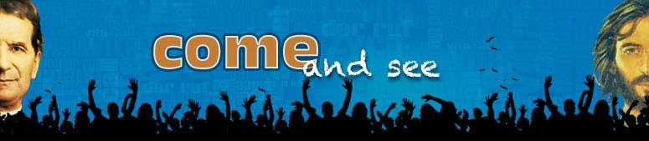

VOCATION CORNER
Summarized by Donna Bucaro
Edited by Fr. Dominic Tran, SDB

Archbishop Dolan on
Family Ministry and
Creating a Culture of Vocations

Recently, Archbishop Timothy Dolan was interviewed by Matthew Bunson from The Catholic Answer about building a culture of vocations. Archbishop Dolan went into detail about the true definition of vocation and his view of vocations today.

Everyone is called to a vocation, whether it is to the priesthood, religious life, diaconate, married life or dedicated single life. Archbishop Dolan said, “We have to believe — it is part of the Catholic worldview — that God has a plan for each of us. He is inviting us to live a life that will bring us back to Him.” He goes on to say that nowadays the married life as a vocation seems to be forgotten. About only half of our Catholic people are getting married; this is an issue. People today are forgetting that through marriage what they are truly doing is “saying that together [they] want to get back (sic) to heaven” and together they will help each other get to their eternal goal. People want to be happy, and true happiness comes only from doing the will of God, and that should be everyone’s main focus.

Archbishop Dolan then goes into detail specifically about the vocation to the priesthood. He comments on his concerns with regard to family support; the role of the family is essential when it comes to the discernment to the priesthood. Archbishop Dolan says that he grew up in a culture where family, neighbors, acquaintances all encouraged the idea of discerning for the priesthood and that same culture of vocations is what we need today in the Church.

If you would like to read more of the interview, please visit the following website:

http://www.osv.com/tabid/7631/itemid/8752/Building-a-Culture-of-Vocations.aspx.
■

Vol. 9, No. 24 – 4 of 4 E-SERVICE December 15, 2011

Advent at Holy Rosary
Fr. Stephen Schenck, SDB

Our parish has been celebrating the season with a variety of offerings which, we hope, are making it beautiful, catechetical, and typical of who we are.

We began, as most parishes do, with the blessing of a large wreath that sits in front of the altar, poised at an angle that makes it easily seen by everyone, thanks to a special stand made by Bro. Sal.

We’re giving the Prophet Isaiah special treatment this Advent. Simple yet readable overviews of Isaiah, Second Isaiah and Third Isaiah, were prepared in the three languages our parishioners use, and made available in bulk for people to take home and read. Along with them, a catechetical instruction is offered before the first reading each Sunday.

A variety of table blessings was also printed for our households to use during the Advent and Christmas Times.

On Saturday, December 10, our parish hosted an Advent retreat for teens, which Fr. Rich helped organize with YM personnel from several other parishes in lower Westchester.

On Monday, the 12th, we celebrated the feast of Our Lady of Guadalupe in grand style. Before the Masses began, the Westchester County executive, Rob Astorino, read a proclamation commemorating our more than 25 years of hosting this annual celebration. He also stayed for the entire Mass and greeted folks afterward. We held two celebrations simultaneously – one in the church and one in the gym. There were close to 800 in the gym and cafeteria, and close to 500 in the church, if you count all those standing both inside and outside. For the church celebration, Fr. Rich and his team of young people prepared videos and skits and had special T-shirts to give away. In the gym, our liturgy committee enthroned the image of the “Guadalupana” against the side wall, hung curtains and filled the space with lámparas, and three-tiered candelabras holding candles in the Mexican colors of green, white and red.

Gospel Roads III
Young Adults

El Salvador

2012
Holy Week Mission
Saturday, March 31
to
Monday, April 9

Challenged to be disciples and missionaries in a short- term experience of faith, fun, fellowship and service to the communities in El Salvador!

An opportunity to walk with Jesus Christ through service to the young and the poor in the spirit of Don Bosco!

Gospel Roads III El Salvador is open to all Catholic young adults interested in a short- term Holy Week evangelization mission in some of the poorest areas of El Salvador.

Registration fee: $500

For more information or to apply, please contact
Meg Fraino at

(973) 761-0201 or

mfraino@salesianym.com
■

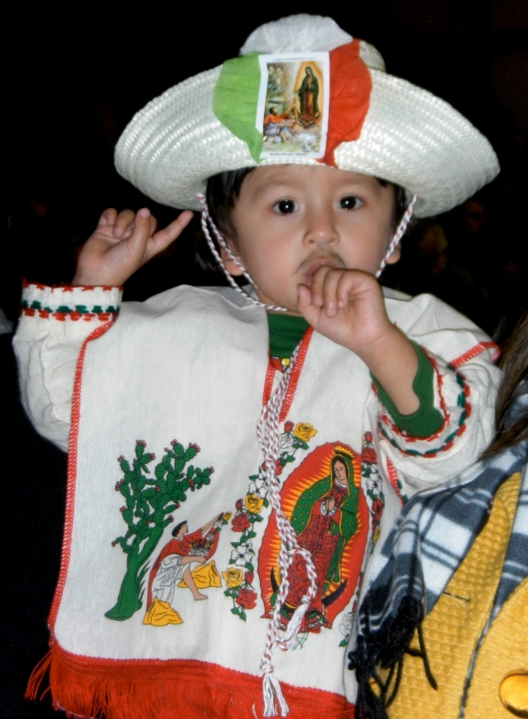

As always, the service included the presentation of roses and a blessing of all the little “Juan Dieguitos” present – in abundance! After refreshments, folks returned to the gym for music and Mexican folk-dancing by our local group, Alma Solana.

On Friday of this week, the “Posadas” will begin. Each evening, pilgrims will gather outside the church and process to a parishioner’s home, accompanied by young adults dressed as Mary and Joseph, and they will carry with them a pesebre, or Nativity scene. Once the home is reached, a sung dialog occurs between Mary and Joseph, and the people inside, representing inn-keepers. Once entrance is granted, prayers and refreshments are shared. The “Posadas” ritual will continue on each evening of the Great Days.

On Saturday, Fr. Rich and his team will host the annual Breakfast with Santa, at the Don Bosco Center, at which we expect between 800 and 1000 children. That evening, the young adults will present their annual “Pastorela,” or Shepherd’s Tale. It changes a bit every year, but is always faithful to the basic structure: shepherds are invited by the angels to go to Bethlehem; on their way, they meet obstacles and lose heart; then they are helped to complete the journey and greet the Christ Child. Integrated with humor and music, it’s a wonderful family preparation for the solemnity of Christmas.

Like all parishes in our archdiocese, Monday, December 19, will be a day of Reconciliation, with confessions available from 2-8 P.M. We hope that day, especially, will lead to an unforgettable celebration of the Christmas liturgies. ■

