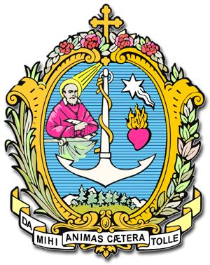
DIREZIONE GENERALE OPERE DON BOSCO
Via della Pisana 1111 - 00163 Roma
The Rector Major

Prot. 15/0385
For the attention of the Provincials
Provinces of EUROPE
My dear Provincials,
A cordial and affectionate greeting from Argentina, where for three days we have had a wonderful celebration for the bicentenary of the birth of Don Bosco, with more than seven thousand young people.
On Sunday afternoon my Vicar, Fr Francesco Cereda, informed me of what Pope Francis said at the Angelus referring to immigrants in Europe and his call to fraternity, solidarity and hospitality. We talked together about it and I think it is an opportune time to offer whatever we can do on our part.
Certainly we have seen for some time, and most dramatically in recent days, the tragedy of refugees and immigrants in thousands fleeing their countries because of war, destruction, hunger and persecution. They arrive in Europe, risking serious danger as they cross the sea and being held to ransom by traffickers.
They come with the hope of finding peace and serenity, beginning a new life, and finding housing and employment. Often they find conditions that are not welcoming, if not actual rejection. In the face of so much tragedy we cannot remain indifferent to their many needs.
At the Angelus Pope Francis Angelus made a strong appeal addressed to Europe: “As we are faced with the tragedy of tens of thousands of refugees fleeing from death by war and hunger, and now travelling in the hope of a new life, the Gospel calls us to be neighbours to the least and the abandoned and to give them real hope. It is not enough to say 'Courage, patience! ...'. Christian Hope - said the Pope - is combative, with the tenacity of people pursuing a safe destination. Therefore, as we draw near to the Jubilee of Mercy, I appeal to parishes, religious communities, monasteries and shrines throughout Europe to put the Gospel into practice and accommodate a family of refugees. This is to be a concrete gesture in preparation for the Holy Year of Mercy. Every parish, every religious community, every monastery, every sanctuary in Europe should host a family, starting from my diocese of Rome. I turn to my brother Bishops of Europe, as true shepherds, to ask their dioceses to support this appeal of mine, remembering that Mercy is the second name of love: 'Whatever you do to the least of these my brethren, you do it to me'(Mt 25:40)."
I also appeal to you Provincials, to ask you with the urgency that you can determine, perhaps with your councils, what each province can do and what you can ask every community and parish to do, to be ready to accept migrant families in our works. We pay particular attention to unaccompanied minors and young people. We should also host one family, four or five people. With a little from everyone we can do a lot, in cooperation with local churches and the local area.
We have just concluded the bicentenary of the birth of Don Bosco. He teaches us to be practical in our response. We were reminded of this by Pope Francis during his visit to Valdocco on 21 June last when he said: "I thank you for your practical approach to things ... The Salesian is practical, sees the problem, thinks about it and takes it in hand."
In the name of charity and evangelical fraternity, as a response to God's call and the cry of Pope Francis, I thank you for the generosity with which you will mobilize all possible resources on behalf of those for whom he addresses this urgent and pressing appeal. I would also be grateful if you let me know what has been decided in every province, when you arrive at practical and timely action.
A fraternal and affectionate embrace


P. Ángel Fernández A.,SDB
Rettor Maggiore

Buenos Aires, 8 settembre 2015
Festa della Natività della Vergine Maria

