Vatican – Recognition of the Martyrdom of the Servants of God Jan Świerc and Eight Companions, Salesians of Don Bosco
24 October 2025
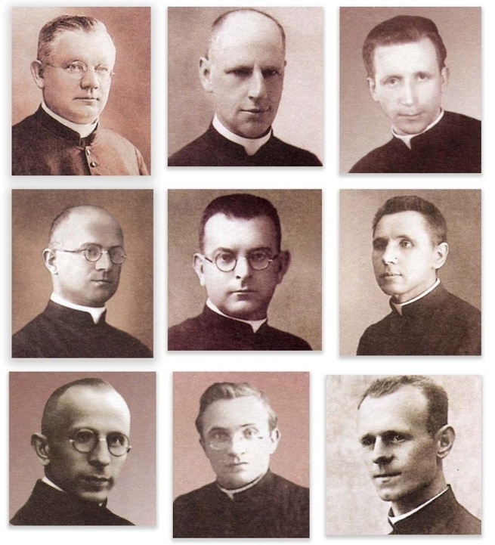
(ANS – Rome) — On Friday, October 24, 2025, the Holy Father Leo XIV received in audience His Eminence Cardinal Marcello Semeraro, Prefect of the Dicastery for the Causes of Saints. During the audience, the Supreme Pontiff authorized the same Dicastery to promulgate the decree concerning:
- the martyrdom of the Servants of God Jan Świerc and eight Companions, professed priests of the Salesian Society of St. John Bosco, killed between 1941 and 1942, in hatred of the faith, in the concentration camps of Auschwitz (Poland) and Dachau (Germany).
This represents the recognition of the martyrdom of nine Servants of God, Polish priests of the Society of St. Francis de Sales (Salesians), who died between June 27, 1941, and September 7, 1942. During the Nazi period, all carried out their ministry in Poland, devoted to pastoral or teaching activities. Eight of them belonged to the Saint Hyacinth Province of Krakow in the Diocese of Krakow and were arrested, tortured, and killed in the Auschwitz concentration camp; Fr. Franciszek Miska belonged to the St. Albert Province of Piła in the Diocese of Włocławek and died in Germany in the Dachau concentration camp.
They are listed in the order proposed by the Positio:
- Fr. Ignacy Antonowicz, aged 51, professor and Rector of the Salesian Theological Studentate in Krakow, died in Auschwitz on July 21, 1941, following ill-treatment.
- Fr. Karol Golda, aged 27, the youngest of the group, theology teacher at the Salesian Institute of Oświęcim (Auschwitz), shot on May 14, 1942, in Auschwitz for having heard the confessions of two German soldiers.
- Fr. Włodzimierz Szembek, aged 59, who entered religious life as a mature man and was ordained at fifty-one, assistant parish priest in Skawa, died in Auschwitz on September 7, 1942, after being tortured.
- Fr. Franciszek Harazim, aged 56, principal of the high school in Oświęcim and theology professor at the Salesian major seminary in Krakow, killed in Auschwitz on June 27, 1941.
- Fr. Ludwig Mroczek, aged 36, who worked in various parishes, the last being Częstochowa, died in Auschwitz on January 5, 1942, after suffering torture.
- Fr. Jan Świerc, aged 64, the oldest and leader of the group, Rector of the Salesian Theological Studentate and pastor in Krakow, killed on July 21, 1941, in Auschwitz.
- Fr. Ignacy Dobiasz, aged 61, confessor and parish collaborator in Krakow, died in Auschwitz on June 27, 1941, due to abuse and inhuman labor.
- Fr. Kazimierz Wojciechowski, aged 37, music and mathematics teacher, director of the oratory and of the Catholic Youth Association in Krakow, killed on June 27, 1941, in Auschwitz.
- Fr. Franciszek Miska, aged 43, native of Upper Silesia, Parish Priest and Rector of the Salesian Institute of Ląd, which the Gestapo transformed into a prison for priests from the dioceses of Włocławek and Gniezno-Poznań, died of exhaustion on May 30, 1941, in the Dachau concentration camp.
For all the Servants of God, the evidence of their heroic acceptance of martyrdom is clear. Amid persecution against the Church, they were aware of the danger they faced. Other priests had already been arrested and killed. Despite being urged by relatives and friends to flee the country, they remained with the faithful—especially the young—whom they continued to guide with prudence and serenity. During imprisonment and even at the hour of death, after enduring all sorts of abuse, they preserved their faith, entrusting themselves to the Lord. None showed bitterness toward their tormentors, and in some cases, words of forgiveness were uttered in their regard. Their martyrdom was the culmination of virtuous lives lived in service to God and in fidelity to the Salesian charism.
“For the Salesian Congregation, for the whole Salesian Family, for the Church of God in Poland, this is news that fills hearts with joy in this Holy Year of Hope,” recalled the Postulator General for the Causes of the Saints of the Salesian Family, Fr. Cameroni. “These Servants of God are shining examples of deep and compelling faith, to the point of shedding their blood, capable of inspiring today’s faithful toward an authentic Christian life.”

