The Strennas of the Salesian Rectors Major:

a journey through time

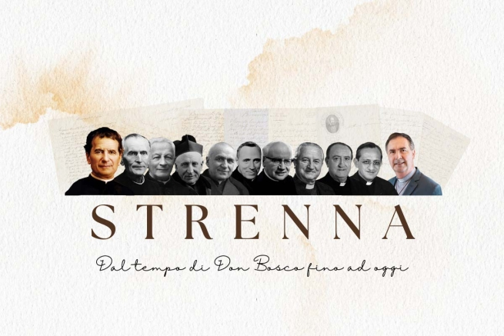
ANS 2023

The tradition of the Strenne (strenna in the plural or simply ‘strennas’ in English) of the Rectors Major of the Salesian Congregation are a particular aspect of Don Bosco’s legacy. This long-standing gesture of care and attention of a Father towards his spiritual sons and daughters has evolved over the decades, being enriched with tools and means to better spread the meaning of its message, but it has kept intact its original value: that of an annual ritual that unites the entire Salesian Family and projects its priorities for the evangelisation and education of the young into the future.
The term “strenna” immediately refers to the element of gift, and in the Italian linguistic tradition from which it came, it is properly associated with Christmas gifts. In the Piedmontese context in which Don Bosco grew up, it was more the case of a tradition of the New Year's gift that the head of the family gave to his children and the proprietor to his employees. January 1st was known precisely as “the day of the strenna”. Thus, in the Salesian context, the Strenna has become a symbolic and significant gift offered by the Rector Major to all the members of the Congregation – and more generally, to those who share the Salesian mission in the world – which is offered at Christmas time, between Christmas and New Year, to inspire the pastoral care for the following year.
From the early days of the Congregation, Don Bosco understood the importance of encouraging and motivating his collaborators through gestures of affection and attention; but it was never just a way of expressing gratitude, but rather a means of renewing commitment to the mission.
Over time, the Strenne have undergone significant evolution. From the first thoughts communicated orally by Don Bosco, we have moved on to the written media, then to graphically presented ones through posters, and more recently also to audiovisual ones, with complex and developed scripts that serve to transmit the same message elaborated in full and detailed form in the evergreen form of the text in an immediate and captivating format.
In recent decades, the Rectors Major have chosen specific themes for their Strenne, transforming them into real declarations of intent for the Salesian community and for the whole world. These themes address topical spiritual, Salesian, church, and social issues, offering a valuable guide to address the challenges of the present and the future.
In this way, the Strenna tradition continues to be a beacon of hope and guidance for all who identify with Don Bosco’s vision.
In view of the presentation and delivery of the Rector Major's Strenna for 2024, the last of Fr Ángel Fernández Artime’s term of office, we would like to retrace the path of the Strenna messages through the years, starting with Don Bosco and then continuing with his other Successors at the head of the Congregation.
We will use the valuable book by Salesian Fr Santo Russo La strenna di Don Bosco e dei suoi Successori (Messina, 2015, Nicolò Edizioni) to develop a way of listing the messages of the Rectors Major over time and trying to identify their sensitivity and particular attention.
It will be a way to rediscover the value, merit and effectiveness of the Strennas and to celebrate Don Bosco and all his Successors.

The Strennas of the Salesian Rectors Major:

Don Bosco

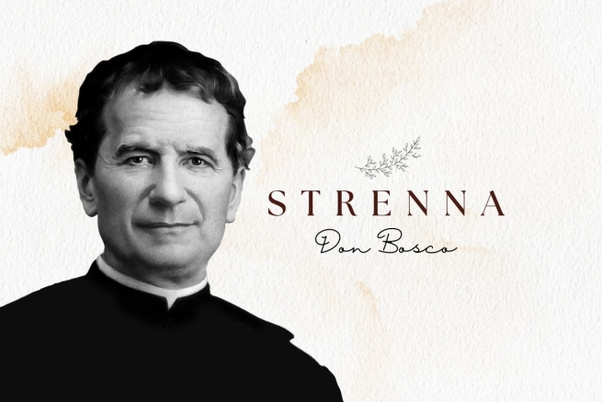
The initiator of the Strenna (New Year Message) tradition in the Salesian Family was, of course, Don Bosco. Already at that time the strenna had a message of pedagogical and educational value and Don Bosco also used to take up the theme during the year, on several occasions, in meetings with his boys, just as today the strenna accompanies the entire course of the pastoral activities of the Congregation.
At the same time, there were also differences: for example, Don Bosco, especially in the early years, not only delivered a strenna, but he used to diversify his messages for those who received them. Some were personal, or others were related to individual groups (Salesians, clerics, students, trade boys, boys attending the oratory...). And, unlike today, there were also “continuous” ones, in the sense that they were presented by Don Bosco over several evenings.
Among the particularities of Don Bosco’s strenne (plural of ‘strenna’) that have been traced, and in reference to Fr Santo Russo’s book La Strenna di Don Bosco e dei suoi successori, we can recall those that originated from dreams (1863-64-68-77); the one in 1862, not dictated by him but personally by Our Lady and which he gave each one on a card; and others containing omens for the future, such as various predictions of the death of a boy or other people (1859-60-62-68-77) – all presented, however, not as something terrifying but as a necessary step in the joyful encounter with the Father.
The recurring themes of Don Bosco’s strenne are his fatherly approach to young people; the passing nature of time on earth, aimed at highlighting the ultimate goal of eternal life; as well as references to useful tools for the life of faith (confession, communion, Marian devotion, prayer).
Although in the biographies it is reported that Don Bosco offered the strenna as early as 1849, the first to be documented was in 1858, although only some of the personal strenna dedicated to clerics and priests are preserved from that year. In the following years it was not always possible to trace the messages of the strenne and some messages are doubtful. However, for 23 years we are sure that they were dictated or written personally by him.
Below are the messages of the Strenne offered by Don Bosco with reference, except in cases where otherwise indicated, to the generic ones valid for everyone:
1859: “Good confessions, open your heart candidly to the confessor...” (Prediction of the death of Michael Magone).
1860: “For my part, I give you all of myself; it will be little, but when I give you everything, it means that I reserve nothing for myself.”
1861: “Frequent and sincere confession, frequent and devout Communion.”
1862: “Make a great effort to listen well to the Holy Mass and each one for his part should strive to promote devoutly assisting at it” (Then Our Lady's strenne to each young person at the Oratory, on an individual card for each).
1863: Dream of the elephant and the Virgin Mary. “Venite ad me omnes; all of you have recourse to her, in every danger invoke Mary and I assure you that you will be heard.”
1864: “At the beginning of this new year, what should I ask you? What to promise you and what advice to give you? Three things. As for something to ask of you, I can only ask of you what is written in my room as the program for this house: Da mihi animas, caetera tolle: I do not ask for anything except your souls, I desire nothing but your spiritual good. Something to promise you? I promise and give you everything I have. For you I study, for you I work, for you I live and for you I am also willing to give my life. Something to recommend? Listen carefully so you can understand me (he tells them about a large globe suspended by the two poles attached to two columns) ... The globe represents the world. The two columns are: one the Blessed Virgin Mary, the other the Blessed Sacrament. They are the ones who really support the world...”
1865: For all Salesians. “Save many souls and among them your own soul”; for the students: “Et erit fides in temporibus suis: divitiae salutis, sapientia et scientia: timor Domini ipse est thesaurus ejus" (and faith will be the stability of your times, abundance of salvation, wisdom, and knowledge; the fear of the Lord is his treasure.)
1866 (of uncertain attribution): Dream: Flood - Mill - Raft... Mary’s promise: “If you are devoted children to me, I will be a merciful mother to you.”
1867: For the students: “Wear the medal of the Blessed Virgin around your neck continuously and invoke this Mother of mercy several times a day with some fervent prayer.”
1868: “Frequent and devout Confession and Communion is a great means of saving our souls.”
1869: For the students at the Oratory (spoken): “Do what for Don Bosco? While you see to the good of the souls of others, do not forget your own.” (Others followed for the various members of the oratory and, through letters, for the houses at Mirabello and Lanzo).
1872:”Good example and obedience.”
1873: “For everyone, then, an example to imitate, a guide to be taken, a protector, and be like St Aloysius; for everyone a friend to be honoured - Jesus in the Sacrament; a mother to be invoked, and let this be Mary Help of Christians.”
1875: We can recognise a strenna behind the words in a letter to Fr Bonetti. “For the boys: Frequent communion. For everyone: do your duty precisely.”
1876: “One thing to do and two friends. The two friends: Good example and Jesus in the Blessed Sacrament. The one thing to do: cherish those small sodalities.”
1877: “Let us always act in such a way that, whatever time death comes, it always finds us prepared” (Prediction of a death).
1878: In a letter to Fr Rua written from Rome on 27 December 1877: “We are at the end of the year, and I am painfully far from our dear boys. Greet them all from me, and recommend for the new year: 1. Fight the habit of smoking and complaining. 2. Be precise in your duties of state, starting from Fr Rua up to Giulio [a family member]. 3. Let us go to communion and pray very much for the houses that have just opened and that are opening up in the missions, where God has prepared abundant harvests for us.”
1879: He instructs Fr Rua to give everyone, in his name, the message (strenna) for the new year. “Unity”.
1880: To all without distinction: “Promote good example by word and deed; put aside even relatively harmless habits in unnecessary things.”
1883: A strenna in the form of a circular addressed to the individual Rectors and one in particular to Fr Lemoyne. (…) “For all the boys. ‘Frequent confession and devout communion.’”
1884: For the students: “Do not steal other people's things, not their time, not their innocence, not their anima verbis et operibus. For the Salesians: “Your first act of charity is for your own soul.”
1886: “Prayer... Frequency of Holy Communion: obedience.”
1888: Among other recommendations for Bishop Cagliero in December 1887, he included: “Strenna: devotion to Mary and frequent Communion.” Then he agreed that it would also serve as a more general strenna.

The Strennas of the Salesian Rectors Major:

Fr Rua

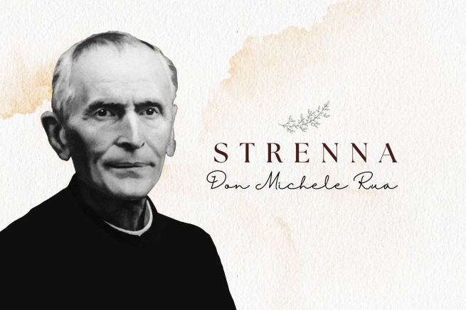
Much has already been written about Blessed Michael Rua and his fidelity to Don Bosco: from the famous episode in which he told him “we will do everything by halves”, to the definition that Paul VI gave of him in the homily at the Mass for his beatification: “Don Rua was very faithful, therefore the most humble and at the same time the most valuable son of Don Bosco”; and then the fact that he was called the “living rule”. In fact, Fr Rua did what he did in his long term of office at the service of the Salesian Congregation within the context of the Strenna: he maintained, carried on and consolidated the work started by the Founder.
When he succeeded Don Bosco in the leadership and government of the Salesian Society, in 1888, Salesian houses had already increased and spread throughout the world; so he gave the Strenna in person to the young people at the Oratory in Valdocco, while sending the message by mail to the different Salesian works, giving a mandate to the respective Rectors to read it on his behalf at the end of the year.
With the increase in works and consolidation of the Congregation, the personal Strenna that Don Bosco gave individually to the boys disappeared: but still, in most cases there was no single form, since the preference was to give a strenna to the Salesians and one to the young people.
18 of them remain from the 22 years of Fr Rua’s term of office, plus one that is doubtful (in 1892, taken from the Salesian Bulletin of the time).
Following the path of the Founder in everything that concerned the strenna (attitude, expectation, meaning, value), Fr Rua remained faithful even in the topics most often addressed: the Eucharist, Confession, Our Lady... In addition to devotion to the Sacred Heart of Jesus, very much a theme of his editions. And, of course, those especially dedicated to Don Bosco could not be missing either.
As for strennas addressed exclusively to the Salesians, reference to the means for a good Salesian life prevails, such as studies and reading, or the observance of the rules and one’s duties to sanctify oneself.
Finally, in terms of structure, Fr Rua’s strennas are characterised by being rather brief and sometimes even set out as the briefest of prayers.
Here, then, are the Strenna messages offered by Fr Rua:
1890: “Literary studies”. Circular Letter no. 4, 27.12.1889. “Take this letter as my strenna for 1890.” (Study of Latin classics. Italian authors. On ways of teaching).
1892: For the jubilee of D. Bosco’s Works – that is, “the Catholic Readings of Turin". “This would certainly be one of the dearest and most pleasing Strennas that could be given for the venerable memory of D. Bosco, in the happy and favourable circumstance of the first glorious Jubilee of the institution of his Works.
1894: "To all Provincials and Rectors: a holy solicitude to respond to the monthly circulars promptly and precisely. Also recommended: 1. That the Rectors, where they can, give a conference to the Salesian Cooperators on the occasion of the feast of St Francis de Sales. 2. We recommend our pupils subscribe to the Catholic Readings. 3. Have the Salesian Bulletin read in public every month and strive to procure new zealous Cooperators.”
1895: “To all the Salesians: Estote ergo perfecti, sicut et Pater vester coelestis perfectus est; - commenting that the greater our commitment to reach perfection, the greater will be the help from God, according to those other words of our Divine Saviour: - Beati qui esuriunt et sitiunt jistitiam, quoniam ipsi saturabuntur.”
1896: - To the Salesians: “Dum tempus habemus, operemur bonum. In every circumstance let us seek what we can do well, and let us do it willingly and generously for the love of the Lord.”
- To the young people: “Estete parti, quia qua hora non putatis, Filius hominis veniet; therefore, study to keep yourself in the grace of God every day, frequently turning to the Blessed Sacrament, the source of grace.”
1897: - To the Salesians: “The Lord tells us: Deliciae meae esse cum filius hominis; and he proves it to us in the Blessed Sacrament of the Eucharist. In turn, we correspond with the most lively devotion to the Blessed Sacrament, and zealously propagate it in others.”
- To young people and their families: “Go to confession weekly, or at least every fortnight, and receive communion in accordance with your confessor’s advice.”
1898: To all Members: "For the love of Jesus, exactness in all your duties of piety and occupations.”
1899: To all: “A special and fervent solicitude to compensate the Most Sacred Heart of Jesus for the offences and outrages received during this century.”
1900: - To the Salesians: “1. Repay Jesus, the victim of his love for us, with keen gratitude, especially by sacrificing our will, through the exercise of willing and cheerful obedience. 2. Console our heavenly Patroness Mary Help of Christians by diligently cultivating the beautiful lily of purity.”
- To the pupils: “1. Solemnise the first Friday of each month with special devotion in honour of the Sacred Heart of Jesus. 2. Ask Mary Help of Christians for the grace to lead a virtuous life, so that it will be followed by a good death in the new century.”
1901: “After having consecrated ourselves to the Heart of Jesus, it must be our constant endeavour to live and occupy ourselves in such a way as to always please that most lovable Heart. - Every morning we will say: ‘O Mary Help of Christians, help me so that on this day I do not displease the Most Sacred Heart of Jesus.’”
1902: "Charitas Christi Urgeat Nos: let us strive to imitate the two examples that the Lord gave us, Saint Francis de Sales and our good Father Don Bosco. - In every difficulty let us remember that we have a most tender and powerful Mother in Mary Help of Christians.”
1903: To the Salesians: “The observance of the Rules and the virtue of humility, which must be the foundation of all perfection: Deus superbis resistit, humilibus autem dat gratiam.
- "For everyone, joy (Servite Domino in laetitia), reminding everyone that true joy comes from the wholeness of the soul and from union with God.”
1904: “For all Salesians, Students and Families, in this jubilee year of the definition of the dogma of the Immaculate Conception, instil a tender devotion to Mary Help of Christians with the firm intention of avoiding, in honour of her, not only serious shortcomings, but also deliberate little faults.”
1905: - To the Salesians: “Zeal in propagating devotion to the Immaculate Virgin Help of Christians”, and “as a practice in honour of Our Lady, fraternal charity.”
- To the pupils and those who live in our houses: "As soon as you wake up and in the evening as soon as you lie down, kiss the medal, or scapular, saying the brief prayer: ‘Blessed be the Holy and Immaculate Conception of the Blessed Virgin Mary Mother of God.’”
1906: "Great diligence in making a good confession, arousing keen repentance for your sins. - In the morning as soon as you wake up, say ‘Sweet Heart of my Jesus, I do not want to offend you anymore.’”
1907: "Frequent Communion with due preparation and convenient thanksgiving, never shorter than a quarter of an hour; - In the morning as soon as you wake up say, ‘Sweet Heart of my Jesus, make me love you more and more.’”
1908: To all: “Practise the virtue of humility, the foundation of our perfection with the prayer, ‘Jesus, meek and humble of heart, make my heart like yours.’”
- To the Salesians: “In deference to the the decree of Venerable attributed to our dear Father, let us add, ‘the study and practice of the preventive system, which he so urged.’”
1909: “Fili, conserva tempus, et tempus conservabit te. Prayer: Jesus in my mind, Jesus in my mouth, Jesus in my heart.”
- To the Salesians he adds: “Undique captare profectum.”
1910: - To the Salesians: “Exactness in obedience; Generosity towards the Most Sacred Heart of Jesus, willingly working and suffering for Him.”
- To the young people: “Charity among them; Avoid complaining and bad language.”

The Strennas of the Salesian Rectors Major:

Fr Albera

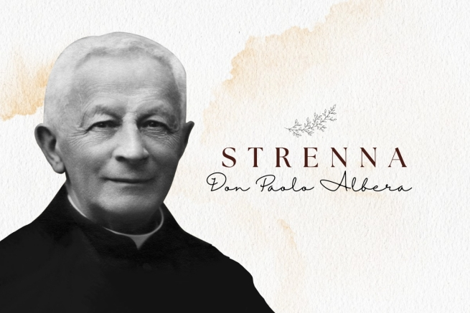
“The Venerable Don Bosco, in educating youth, made such effective use of the ‘good word‘ spoken each night with loving fatherly simplicity, that he was able to ensure that this very important educational medium was uniquely effective on the last day of the year. It was the ‘Strenna’, that is, the Christmas or New Year's gift, which seemed more precious to our good father than any other gift and therefore he enjoyed offering it to his beloved boys (...). Those dear moments remained indelibly imprinted in our hearts.” These were the words the Second Successor of Don Bosco, Fr Paul Albera, used in 1916, to describe the meaning, value and effectiveness of the Strenna.
Fr Albera, like Fr Rua, always pursued the direction of great fidelity to Don Bosco – so much so that he was called “the little Don Bosco” – and if one wants to trace a difference with Fr Rua, it is that Fr Albera had two models to imitate: the founder and his first successor. His term of office was described as being “in the footsteps of Don Bosco and Don Rua” and Pope Pius X himself outlined the program: “Do not deviate from the customs and traditions introduced by Don Bosco and Don Rua.” With such an imprint, it is therefore not surprising that Fr Albera’s Strennas follow in the footsteps of his predecessors.
Instead, what was new with Fr Albera is that his Strennas were reported for the first time in the Acts of the Superior Council (at least the final one in 1921); and that there is one expressly addressed to the Salesian Past Pupils. In 1911 Fr Albera presided over the first of their International Congresses.
Fr Albera was Rector Major for 11 years (from 1910 to 1921), and we received 9 strennas from him, which tend to be quite brief and concisely written, but at the same time rich in spiritual suggestions.
Among the recurring themes of Fr Albera’s strennas, explicit references to Don Bosco could not be missing as an example to be imitated and invoked; but even where the reference is not explicit, the memory of Don Bosco is always present and proposed as a model. As for the other topics, the idea of the Strenna continued as a useful tool to recall the means for growth in Christian or religious life.
Finally, considering that Fr Albera’s term of office was largely marked by the "useless slaughter" of the First World War and its long trail of death and destruction, the invitation to live life from a Christian perspective, involving commitment and sacrifice and looking to the afterlife, became even stronger.
Here, then, are the Strenna messages offered by Fr Albera:
1913: - For the confreres: "Make the prescribed spiritual reading regularly and with commitment. Don Bosco highly recommended it and attached so much importance to it. If we can, then do it together, but no one should in any case deprive themselves of this spiritual fodder and should supplement it in some way when reasonable reasons prevent them from being there with the community.”
- For the boys: “Holy love for the angelic virtue. Everyone knows how often and insistently Don Bosco returned to this topic when speaking to young people. As we approach the 25th anniversary of his departure from this earth, there is no better way to recall his memory than by instilling in our young people a particular commitment to observe in their thoughts, affections, words and deeds the virtue that he held most dear and that he wanted above all to shine in his children.”
1914: – For the confreres: “Make the monthly rendiconto regularly, humbly and simply.”
– Repeat to the young people in our institutes what our Ven. D. Bosco said, “Make sure that the devil never finds you unemployed.”
1915: – For the Salesians. “I will pay a very fervent visit to Jesus in the Blessed Sacrament every day. And I will ask for the grace for me and my confreres to persevere until death in our vocation.”
- For the young people. "I will make Dominic Savio’s motto my own: ‘Death but not sin.’”
1916: - For the Salesians: “The constant practice of charity ut sint unum, that is, so that they truly form one heart and one soul.”
– For our dear pupils: “Be brave everywhere and always, and never let yourselves be overcome by human respect in the practice of religion and virtue.”
1917: – For the Salesians. "We show our affection for our Venerable father Don Bosco by scrupulously observing the Constitutions he has given us and that the Church has approved.”
– For the young people. “Make every confession as if it were the last one of your life.”
1918: – “Seize every opportunity to practise mortification.”
– For the Past Pupils: "...Heartfelt unity of all members with their own association and of all associations with each other.”
1919: – “I will now be more generous in responding to the good inspirations that the Lord sends me.”
1920: – For the confreres: “May we serve the Lord with great delicacy of conscience.”
- For the young people: “Ensure the effectiveness of confessions through a commitment to put your good resolutions into practice.”
1921: – For the Salesians: “Convinced that humility is the foundation of perfection, we will endeavour to practise it as best we can in thoughts, words, and deportment.”
– For the young people: “Never forget that God finds his delight in a soul adorned with his grace. If, on the other hand, the soul is stained by sin, God abandons it, and it becomes the sad dwelling place of the devil. Therefore, be on guard against sin!”

The Strennas of the Salesian Rectors Major:

Fr Rinaldi

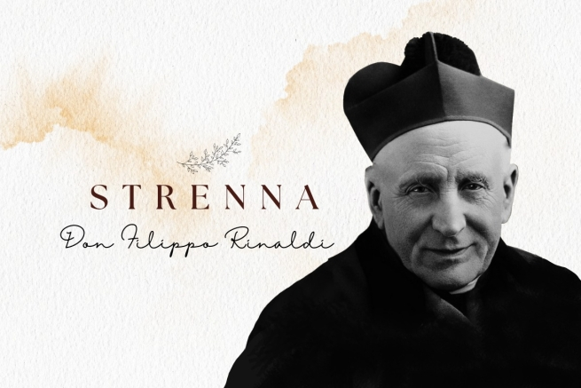
Don Bosco’s third successor at the head of the Salesian Congregation was Fr Philip Rinaldi, Rector Major for 9 years from 1922 to 1931. The Salesian historian Fr Giovanni Battista Francesia said that he lacked “only the voice of Don Bosco, he has everything else”; while Fr Egidio Viganò, another Rector Major, called him “a genuine witness and interpreter of the Salesian spirit” and ”a prototype of pastoral kindness.”
Animator of lay movements – so much so that it was he who started the Institute of the Volunteers of Don Bosco – promoter of a spirituality of work, teacher of spiritual life, Fr Rinaldi, now recognised as Blessed by the Catholic Church, was the standard-bearer of Don Bosco’s fatherliness, and all these traits are also found in the Strennas he delivered over the years.
10 Strennas of the 11 years of Fr Rinaldi’s term of office have been identified; the missing one is from the year of his election in 1922, probably because Fr Albera died in October 1921 and since Fr Rinaldi was elected in April 1922, there was no strenna.
Fr Rinaldi’s strennas, both in form and content, follow on from those of his predecessors. The twofold message, one addressed generically to Salesians and the other to young people, almost always continues; but it is with him that we begin to see ideas dedicated more clearly with greater frequency to other groups of the Salesian Family – Salesian Cooperators and Past Pupils – to whom Fr Rinaldi presents simple ways to live the Christian life well.
The strenna texts propose a simple kind of ascesis accessible to all; the message is brief and clear, often an invitation to do or avoid something, to live a more Christian or religious life. Characteristic, in form, is the strenna of 1930: three invocations to Don Bosco, one different from the other for each group to which the strenna is directed.
For Fr Rinaldi, too, the imitation of Don Bosco is at the centre of his thoughts and work. Some strennas are almost entirely dedicated to him in a special way, and he still remains the reference to be imitated. However, there are other shining examples of Salesian life indicated as a model (Fr Rua) or of youthful holiness, not exclusively Salesian (we find Dominic Savio but also Aloysius Gonzaga).
And as well as the traditional themes of devotion to the Eucharist and Mary, there are also references to topical events in the life of the Church in 1925 and 1926, where there are direct references to the Jubilee of that period.
Below are the Strenna Messages offered by Blessed Philip Rinaldi:
1923: - To the Salesians: “Let us try to imitate the Servant of God Fr Rua in the exact observance of religious life.”
- To the young people: “Let them strive to follow the examples of Dominic Savio in their devotion to Jesus in the Blessed Sacrament.”
1924: - To the Salesians. “Exact observance of the Constitutions”.
- For the young people. "I will make Dominic Savio’s resolve to strictly observe the house rules my own.”
1925: To the Salesians: “Make your meditation well on a daily basis. It must shed light on the works, words and thoughts of the whole day” (On the 50th anniversary of the Approval of the Constitutions).
- For the young people. “Grow in devotion to Jesus in the Blessed Sacrament and to Mary Help of Christians, to spend the Holy Year well.”
1926: - To the Salesians. “Seek souls and not money, honours, or dignities” (quote from Don BoscoBs recommendations to the first missionaries)”.
- To the young people: "Pray to Mary Help of Christians for the Missionaries and for unbelievers.”
- To the Past Pupils: “Promote the propagation of the Faith by word and whatever means are within your reach.”
1927: - To the Salesians: “Observe the great silence from evening after prayers until breakfast the following day, as Don Bosco wanted, and as the Rule prescribes.”
- For the young people. “Honour Saint Aloysius Gonzaga by imitating his virtues and devoutly calling on him”.
1928: - To the Salesians and Salesian Cooperators. “Qui elucidant me, vitam aeternam habebunt”.
- To the Young People and Past Pupils. “Ecce Mater tua! Behold your Mother!”
1929: – “Study and imitate the holiness of Don Bosco 1. in his piety; 2. in his virtues; 3. in his works” (taken from the “Reminders” for the Spiritual Exercises of the year, which, however, usually referred to the strenna).
1930: - To the young people: “That we may be devotees of Jesus in the Blessed Sacrament and Mary Help of Christians, Blessed Don Bosco, pray for us!”
- To the Past Pupils: “So that we may be tireless in work in the sense and in the way that you were, Blessed Don Bosco, pray for us!”
- To the Salesians: “So that we may love youth as you loved them, Blessed Don Bosco, pray for us!"
1931: - To the Salesians. “Let us make Blessed Don Bosco better known. Let Rectors make the life and works of the Blessed available to the confreres. Let everyone talk about him, citing his examples in conferences, in good nights and even in school and in conversations”.
- For the young people. “Escape idleness even in recreation by using time well in imitation of Blessed D. Bosco”.
– For the Past Pupils: “... “Christian correctness and reserve in manners and words, remembering the example of Don Bosco”.
1932: To the priests: “Missa attente celebretur: let the Holy Mass be celebrated with care”.
- To clerics and brothers: “Sanctum Sanctorum peramanter visitatur: visit Jesus in the Blessed Sacrament out of love”.
- To boarders, day students and those coming to the oratories: “Listen carefully to Holy Mass and prepare to receive the sacrament of Holy Communion or at least spiritually”.
- To Past Pupils: “Make every sacrifice to attend Holy Mass recollectedly every Sunday and feast day”.

The Strennas of the Salesian Rectors Major:

Fr Ricaldone

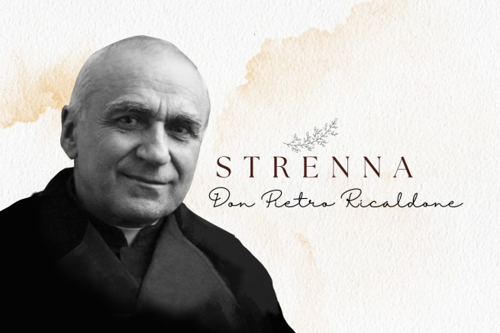
The fourth Successor of Don Bosco at the head of the Congregation, Fr. Pietro Ricaldone, was affectionately called the "fifth Don Bosco", for the person that he was. He was the Rector Major for almost 20 years (1932-1951) and lived at a time when direct contact with the founder for reasons of age was beginning to diminish slowly. For this reason, he worked hard to ensure that the Salesian tradition was handed down correctly, and hence was also called "the 'codifier' of Don Bosco's spirit".
His mission was to consolidate not only the spirit, but also the Salesian mission and consequently the structures that sustained it. It was during his leadership that great expansion and quite a few satisfactory events took place: Don Bosco was canonized as Saint (1934), Mother Mazzarello (1938) and Dominic Savio (1950) were also beatified. Besides these milestones, he also enlarged the Basilica of Mary Help of Christians in Turin, laid the foundations of the future Library of Christian Doctrine (the 'LDC' publishing house), mainly to facilitate the training of teachers of religion and to produce books and teaching material. In 1940, he obtained the decree from the Sacred Congregation of Vatican, with which the Pontifical Salesian Athenaeum (PAS) was erected in Turin: He also began the construction of the Temple of Don Bosco at Colle (Becchi) and set up a highly valued Industrial Technical School.
At the same time, he had to also face some dark pages of the history, such as World War II and the religious persecution in Spain. Through all this, however, the abandonment to Divine Providence and the commitment to transmit Don Bosco in his genuine and integral form always endured.
With him, moreover, some of the typical traits of modernity and the role of the Rector Major as it is usually understood today began to emerge. For example, he was the first to start travelling around the world to meet all his confreres scattered everywhere.
Through the strenne (the themed new year messages to focus upon, given by the Superior of the Salesian Society) issued during his period, (all of which are well documented in the minutes of the Superior Council), he was able to unite tradition and innovation. For his strenne, he kept his gaze fixed on Don Bosco and adapted a shorter and a more concise form. He was also the first of the Rectors Major to publish a special 'Commentary' on the strenna as well.
Moreover, with him, the strenna became more and more a message and an invitation for the entire Salesian Family and ceased to be a specific one depending on the recipients (the only exception being the 1935 strenna).
His first strenna was the one on the theological virtue of Charity (1933), almost as if to make it a programmatic manifesto, referring to the heart of the Gospel and Don Bosco's life.
Several of his strenne, on the other hand, are linked to historical events, which Don Ricaldone took advantage of, to make them part of a well-studied project of knowledge to know the actual person of Don Bosco. In this sense, for example, reference to Salesian Testimonies that lived the Salesian charism and through it were raised to the honours of the altar could not go unnoticed in his strenne.
Other strenne - all from the wartime and post-war period - complete the cycle of the theological virtues and the four cardinal virtues, and thus also constitute an invitation to face the various vicissitudes of life with faith, hope and charity, and to gain strength through prudence, justice and temperance in order to change the world for the better.
Another group of Fr Ricaldone's strenne again highlight Don Bosco, proposing him as a model for the Salesian and young people to implement his three great loves: Jesus in the Blessed Sacrament, Mary Help of Christians, and the Pope.
Finally, work, both intellectual and organizational, was a strong point in his life. (Fr Ricaldone also wrote extensively on education, agrarianism, Salesian formation and spirituality, even received a great recognition for it).
Topics proper to Don Bosco and valid for any of his disciples such as: love for the young (1951), poverty (1936) and humility (1952) were never lacking focus in his messages.
Below are all the Strenne left by Fr Ricaldone to the Salesian Family:
1933: To everyone: 'Think well of All, speak well of All, do good to All'.
1934 (Canonization of Don Bosco): 'Don Bosco encourage us to sanctify ourselves with purity of life. Holiness is purity'.
1935: - To all: 'Faithfulness in following the teachings of St John Bosco in all things'.
- To the Salesians: 'Fidelity to the Constitutions, Regulations, traditions, methods and works proper to the Congregation'.
- To the students: 'Faithfulness to the Rules and to the Eucharistic tradition'.
To the Past Pupils: 'May each of their houses be a true little Salesian house where our Father reigns with his spirit.
1936: 'Knowledge, love, and the practice of evangelical poverty procure us temporal happiness and eternal goods.
1937: 'Let us cultivate Eucharistic piety according to the teachings and practice of Saint Don Bosco'.
1938: 'Let us sanctify our work in the spirit and works of Saint Don Bosco'.
1939: 'Following the example and spirit of St. John Bosco let us sanctify joy, recreation and entertainment.
1940: 'St. John Bosco invites us to always uphold catechetical teaching and religious formation in the highest honour, in our homes and especially in the Festive Oratories'.
1941: "To commemorate the first Mass celebrated by St. John Bosco on 6 June 1841 we honour the Catholic Priesthood by making known its greatness and zealously fostering priestly vocations".
1942: "Let us live the life of charity intensively. Charity towards God, loving him above all persons and things; charity towards our neighbour in thought, word and deed'.
1943: 'Let us open our hearts to hope: God is our Father. Mary Help of Christians is our Mother. From Heaven watch over us, Father, Teacher, Guide, St John Bosco'.
1944: 'Let us approach God with fullness of faith'.
1945: 'Utmost prudence in word and deed'.
1946: 'Let us practice the virtue of justice towards God and neighbour'.
1947: 'WE ARE STRONG: - in overcoming passions; - in enduring and overcoming trials; - in winning many souls to God'.
1948: 'Let us practice the virtue of temperance in the use of the senses and the care of the body'.
1949: 'Let us increase in ourselves and propagate devotion to Mary Help of Christians everywhere and among everyone'.
1950 (Holy Year): 'Know, love, defend the Pope'.
1951 (Beatification of St Dominic Savio): 'Blessed Dominic Savio encourages us to faithfully practice the educational system of St John Bosco.
1952: "In this world, ravaged by pride, there is an urgent need to practice humility. Humility is the radiance of truth. Humility makes life joyful in families, communities, and society. Humility is the sure shield of chastity".

The Strennas of the Salesian Rectors Major:

Fr Ziggiotti

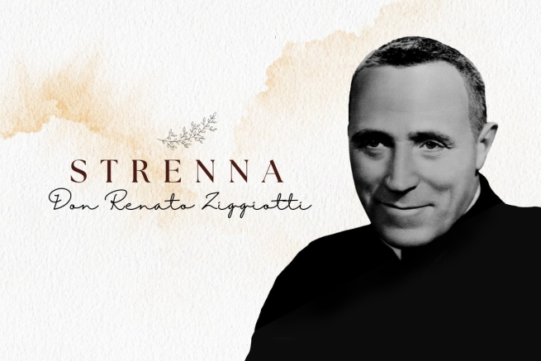
Fr Renato Ziggiotti led the Salesian from 1952 to 1965, elected to this mission by the 27th General Chapter in the history of the Congregation founded by Don Bosco. He was the first Rector Major not to have met Don Bosco directly – although he made his first vows before Fr Rua, the founder's first heir.
During his term of office, the Congregation had to face great challenges, but it also reached important goals. As Rector Major he worked with all his might for the unity of the Congregation and its spiritual and material reconstruction, which the Second World War and other wars in various parts of the world had affected.
At the same time, he was able to see with satisfaction the construction of the Basilica of St John Bosco in Rome, the sanctuary of Don Bosco at Colle Don Bosco and managed to bring the Pontifical Salesian University of Turin to Rome. Under his leadership, moreover, the Congregation’s expansion and spread throughout the world reached its zenith, at least until today.
Fr Ziggiotti personally took part in the first three sessions of the Vatican Ecumenical Council II (1962-1965) and developed the process undertaken by Fr Rinaldi, becoming the first Rector Major to personally meet all the Salesians scattered throughout the world.
He was also the first Rector Major Emeritus: in 1965, during the 19th General Chapter, given his age and the new direction that the Congregation had to take after the Council, after 13 years of governance of the Congregation, he humbly resigned to pass the baton to others, and quietly stepped aside. He spent the last years of his life in prayer,reflection, pastoral service, first at Colle Don Bosco as Rector of the church, then at Albarè di Costernano, in the Veneto where he was born.
For Fr Ziggiotti too, as for his predecessors, the strenna was “a thought”, “an appropriate recommendation”. And for him too the strennas referred to the tradition of Don Bosco and his successors; but the need to adapt them to the times was more evident.
Like those of his predecessors, Fr Ziggiotti’s strennas were brief, simple, easily remembered and very practical. Going back to former times, in several cases there was more than one, that is, there were several strennas per year, dedicated to the different Salesian groups.
It has been said of Fr Ziggiotti: “He lived for God, he lived for the Church. He lived for Our Lady and Don Bosco. Consequently, he lived for his confreres and their mission.” And his strennas are a testament to these characteristics. The first one, in 1953, was dedicated to the Eucharist; the last one, in 1965, reminded the Salesians of Don Bosco’s three loves: love for the Eucharist, Mary Help of Christians, and the Pope. And the same themes recur several times in his 13 Strennas, all now preserved in the Acts of the Superior Council.
Other strennas, as mentioned, were linked to the times, to events of the
Church and the Congregation: such as some significant anniversaries (centenary of the death of Saint Dominic Savio or of the presentation of the Constitutions or the Apparitions at Lourdes), or other events of worldwide relevance (above all, the Ecumenical Council).
Finally, among the recurring themes, returning to the most genuine expressions of Don Bosco, there are references to useful tools for Christian life and personal sanctification, especially in the messages addressed to young people, Past Pupils and Salesian Cooperators.
Below are the Strennas bequeathed to us by Fr Renato Ziggiotti:
1953: “Let us all live always in the heart and spirit of St John Bosco, cultivating faith and love for Jesus in the Holy Eucharist”;
1954: “Let us all live always in the spirit, in the heart and in the angelic purity of Mary Immaculate Help of Christians”;
1955: "St Dominic Savio points out the path of virtue to our young people ; this reminds parents and educators of the wise pedagogy of St John Bosco”;
1956: "Let educators, students, past pupils and Salesian Cooperators give the utmost importance to religious education, support of the faith and safe guidance in Christian life”;
1957: To young people and Cooperators. “On the centenary of the death of Saint Dominic Savio, may he be a model to all of firmness of character and fidelity in the fulfillment of our duties towards God and our neighbour”;
- To the Salesians. "Let us look to the Venerable Fr Rua to imitate his wonderful life of union with God, of intense work and attachment to the Rule and Don Bosco”;
1958: "On the Centenary of the Apparition of the Immaculate Conception in Lourdes, let us honour the Blessed Virgin with the devout recitation of the Holy Rosary";
1959: To the Salesians: “On the centenary of the presentation of the Constitutions to the Supreme Pontiff Pius IX, our Holy Founder recommends their exact observance and, in particular, fidelity to meditation in common and the monthly rendiconto”.
- To young people, Cooperators, and Past Pupils. “Holy Mass is the most perfect prayer of the Christian. Let us learn to take part in it with greater faith, devotion and spiritual profit”;
1960: To the Salesians: “Let us protect morality with angelic modesty, regular, fatherly and patient assistance, with sacramental and Marian piety”.
- For the young people. “Servite Domino in laetitia. Be joyful without ever offending the Lord.”
- To Past Pupils and Cooperators. "In the family and in society let us work together so that amusement is upright and healthy"
1961: “Let us say the Hail Mary for peace at home every day. Pax Domini sit semper nobiscum. Peace be with us”;
1962: “Let us swear allegiance to the program that Don Bosco left us”.
- To the Salesians. “Oboedientia et pax”;
- To the students. “Let us direct our pupils to the star in our firmament. Let them make the Sacraments a campaign: Jesus source of grace and Mary the channel that transmits it to us; Jesus perennial light and Mary the star that guides our way; Jesus the fire that burns our miseries and Mary all beautiful, all holy, immaculate radiance of holiness”;
- To the third Salesian Family. “To the third Family of Salesians in the world we point to the heart afire and launch them into the apostolate of good example and in the defence of the Faith”;
1963: “Credo unam, sanctam, catholicam et apostolicam Ecclesiam”;
1964: Dream of the Diamonds. “Pia Salesianorum Societas qualis esse debet”. “Live the life of the universal Church in our Family, in humility of spirit, in holiness of life and in zeal of apostolate”;
1965: “On the hundred and fiftieth anniversary of the birth of St John Bosco 1815-1965 let us cultivate in ourselves and spread among our students and faithful the devotions dear to Don Bosco: the Eucharist, Mary Help of Christians and the Pope, and in a particular way the Eucharist”;
- To young people: “Character education”.
- To Cooperators and Past Pupils: “Education of children in the family”.

The Strennas of the Salesian Rectors Major:

Fr Ricceri

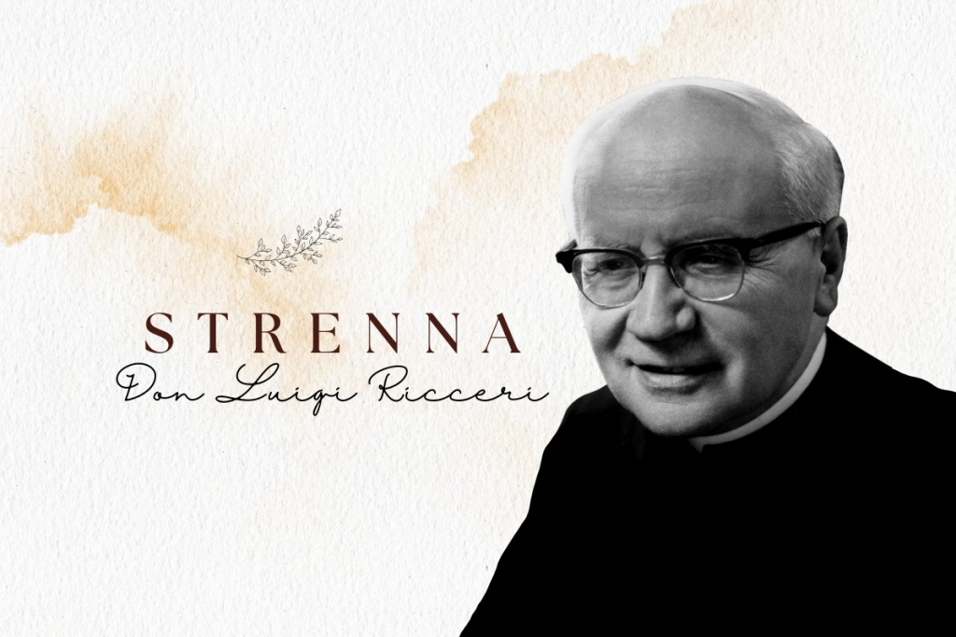
In 1965 the Salesians at their 19th General Chapter elected Fr Luigi Ricceri as their leader. He held this position for 12 years from 1965 to 1977. It was with him that the Congregation embarked on the path of renewal to which the whole Church was called in those years, after the Second Vatican Council.
Much of his term of office was devoted to the preparation for the Special General Chapter, the 20th, and the 21st General Chapter, for the renewal of Salesian religious life. He opened the doors, in the Congregation, to dialogue, began to operate the new structures of Government of the Congregation (the Regional and the various Councils), worked to make the new Constitutions understood and accepted, began the first reshaping of Salesian works and the project for the Salesian Family.
As Fr Santo Russo SDB recalls in his book The Strenna of Don Bosco and his successors [The book is in Italian], “During his term of office he transported Headquarters from Turin to Rome, celebrated the centenary of the first missionary expedition, launched the temporary Salesian missionary volunteering process, reorganised the press office. After 12 years of intense work governing the Congregation, he felt the need, like his predecessor Fr Ziggiotti, to pass the baton to others, and on 15 December 1977, he resigned.”
Fr Ricceri carried out his term in a very delicate and turbulent historical period: the period of the crisis that also involved the Salesian Congregation after the Second Vatican Ecumenical Council and the 1968 period. He experienced these difficult years of renewal and contestation not without pain, misunderstanding, correction of deviations, tensions, but firmly and decisively, remaining faithful to the spirit of Don Bosco, fighting for the unity of the Congregation, for its just renewal and adaptation to new needs, in a spirit that has been described as “dynamic fidelity”.
And from his own words you can tell what the strenna meant to him. In fact, in the Introduction to the 1968 Strenna commentary he said: “Strenna, first of all, means gift, it means friendship, family, familiarity... In the tradition of our good families there was precisely the strenna that was received on New Year's Eve, and which then became more sophisticated ...; but the substance remained: the son, the daughter received this gift from their parents, from their relatives.”
And in presenting the 1973 strenna, he added,”It does not have a simple sentimental value, it is not a rhetorical slogan, but it comes to give all the members of our family a true program of action and life that, when implemented, unites us in the same intentions; and while it is very useful to the individual, it is of no small advantage to the community that feels committed to a united effort towards a goal that interests our common vocation.”
After Fr Ricaldone, Fr Ricceri also followed up with a presentation, an official commentary, usually not very long. In addition, the strenna began to be offered in broad terms to all the members of the Salesian Family. In his 12 years as Rector Major, he left 13 strennas, handed down 9 through the Acts of the Superior Council and 4 from the Salesian Bulletin of the time.
Unlike those of his predecessors, the strennas, at least for the most part, were developed and quite lengthy. Many strennas were determined by particular events in the Church or the Congregation, especially the Second Vatican Ecumenical Council.
However, there were also references to ordinary themes of Salesian spirituality: love for and fidelity to Don Bosco, devotion to Mary Help of Christians and the Eucharist; charity towards the poor and needy (1971); commitment to the education of young people, catechesis, vocations; and the Salesian missionary dimension.
Here are the strennas Fr Ricceri gave to the Salesian Family:
1966: “In the jubilee year of the birth of our Father, I invite the members of the Salesian Family and those linked to it to offer him as a welcome tribute an effective interest in the directives of the Ecumenical Council. In particular, the Salesians and the Daughters of Mary Help of Christians, to commit themselves to studying and generously implementing the ‘Decree on Religious Life’; the Cooperators and the Past Pupils the 'Decree on the Apostolate of the Laity', the young people the ‘Constitution on Liturgy’”;
1967: “For a more apostolically fruitful action and more respectful of human values within the religious and social community, let us live the spirit and practise the method of ‘Dialogue’ desired by the Council”;
1968 (Year of Faith and Marian Centenary Year): “Welcoming with filial devotion the exhortation of the Supreme Pontiff for the centenary of Sts Peter and Paul, I invite the entire Salesian family to celebrate the Year of Faith with a generous and fervent resolution to deepen the authentic value of the Faith; to revive awareness and effectiveness of it in their lives; to bear witness to it today with Christian consistency. May the Virgin Help of Christians, valid support and defence of the Faith, on the Centenary of the consecration of her Basilica in Turin, comfort us in our commitment”;
1969: “’The Eucharistic Mystery commits the entire Community of the faithful and demands from each individual member of the faithful a very personal and vital devotion.’ In the light of these words of Paul VI we make the Eucharist and our Eucharistic life: the Centre of the Educative Community, the soul of family life, the source and support of our witness and our apostolate”;
1970: “The fundamental law of human perfection, and therefore also of the transformation of the world, is the new commandment of charity (cf. GS lll, 3B). Inspired by this statement of the Council and the living example of Don Bosco, we rediscover the authentic meaning of charity in the Gospel message; we verify the effectiveness of charity in our personal, family and community life; we renew our commitment to the service of charity that we owe to the ecclesial community and to all our brothers and sisters”;
1971: “Faced with the very serious problems of underdevelopment, let all of us who in any way feel we are members of the Salesian Family courageously commit ourselves to living and implementing Don Bosco's charism for the spiritual, cultural and material promotion of what he called ‘poor and abandoned young people’. In particular: - Confreres, Daughters of Mary Help of Christians, Cooperators and Past Pupils should become effectively aware, each according to their circumstances, of this essential vocation to the Salesian spirit. According to the situations and needs of individual countries and always with a Christian sensitivity, let concrete activities are be promoted for the social and moral uplifting of young people. let us educate young people in our works to a keen and open sense of social conscience and start practical initiatives of service to others”;
1972: “To make the mission of Don Bosco current and valid among the people of our time, especially among youth, in the spirit and according to the directives of the Special General Chapter, let each member of the Salesian Family commit themselves to a decisive personal renewal of their spiritual life, an indispensable foundation for effectively renewing the mission entrusted by Providence and the Church to the Family of Don Bosco”;
1973: “Let the Salesian Family regain the vitality of its origins by committing itself to living an intense missionary climate”;
1974: “Faithful to the teachings and example of Don Bosco, let all members of the Salesian Family consider it a dutiful crowning of their educational education: - to guide and form apostolic vocations in the Church; to dedicate themselves with particular care to those called to the priestly and consecrated life; to promote and increase Salesian vocations, to fulfil the mandate to continue the charism of Don Bosco in the Church”;
1975: "In the light of the Centenary of the Salesian Missions, let the Family of Don Bosco, responding with a filial sense to the Pope's invitation for the Holy Year, undertake to live 1975 fully as a year of conversion to God, rediscovering the values of the Christian and Salesian vocation, reconciliation with our brothers and sisters in communion of faith, love, apostolic action, evangelisation inspired by the ‘missionary project‘ indicated by the Help of Christians to Don Bosco".
1976: “In 1976 our Family will remember the Centenary of the birth of the Association of Salesian Cooperators, the Regulations for which Don Bosco published in that year. While we thank the Lord for the effective collaboration that the Cooperators have lent to our Mission in many ways for a century, I invite the Salesians, the Daughters of Mary Help of Christians, the Past Pupils and other groups of the Salesian Family, to renew their commitment to get to know, promote, animate the Salesian Cooperators, Don Bosco's original intuition so they can share responsibility, and call lay people to an apostolic commitment in the Church”.
1977: “This year the Salesian Congregation celebrates the 21st GC in its history, exactly one century after the first Chapter called by Don Bosco himself. In this significant circumstance, the Salesians are invited to verify the effectiveness of the ‘renewal of the Congregation’ requested of them by the post-conciliar period in the light of the great reflection that the Church is making on the fertile theme of Evangelisation. I consider it most beneficial to extend an invitation this year to all members of the Salesian Family, to verify their commitment to proclaim Christ and bear witness to him with their lives. Individuals and groups of our Family will try to fulfil this commitment together, from the most current perspective of Don Bosco's apostolic project”.

The Strennas of the Salesian Rectors Major:

Fr Viganò

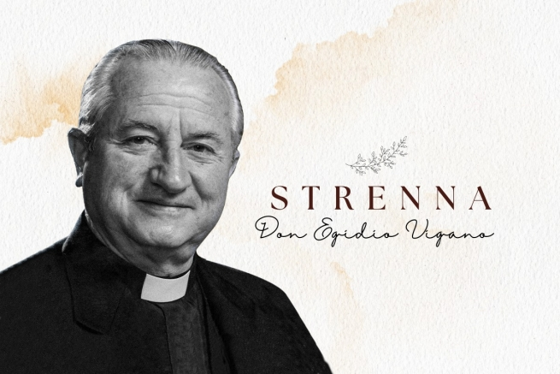
The 7th Successor of Don Bosco, Fr Egidio Viganò was a Lombard by birth, but South American by adoption. Endowed with great intellectual and organisational capacity, very active also in the service of the Church and the Pope, he was also described as “the American Don Bosco”, leading the way for subsequent Rectors Major who have come from that continent.
Born in 1920 in Sondrio, he left as a missionary for Chile already in his initial formation, and in his new land he was appreciated for his kindness, friendship and culture, so much so that the Salesian Cardinal Raúl Silva Henríquez would call him to be his “advisor” and would want him with him as a “peritus” at the Second Vatican Council. After a Salesian life spent in formation, during the 21st General Chapter, in 1977, he was elected Rector Major, a position he held for three terms and a total of 18 years.
He held numerous important positions from the Pope, participated in six Synods of Bishops – again by papal appointment – and in 1986 was invited to preach the Spiritual Exercises to the Pope and the Roman Curia. The last year of his life was marked by illness and suffering, but lived with hope, love and dedication, without failing in his commitments.
In summarising his life, Fr Santo Russo, SDB, author of the text The Strenna of Don Bosco and his Successors, writes: "“He gave the Congregation and the Salesian Family a ‘more ecclesial’ sense and feeling, urging them them to new openings: renewal of the Constitutions, Project Africa, opening to the East, relaunching of devotion to Mary Help of Christians (1984), Entrustment of the Congregation to Mary, recognition of the Mary Help of Christians Association (ADMA) as part of the Salesian Family, call to renew devotion and preaching according to the directives of Paul VI (Marialis Cultus, 1978), rediscovering the ‘Oratory criterion ’ as our method of pastoral care.”
Three times, during his mandate as Successor of Don Bosco, he toured the world to meet Salesians and members of the Salesian Family, and bring enthusiasm in the name of Don Bosco.
For Fr Viganò, too, the Strenna was an important tradition that always refers to Don Bosco to inspire and guide Salesian planning. And, as he said in the presentation of the 1985 Strenna, “it not only represents a sign of the loving presence of Don Bosco, through his Successor, but becomes a stimulus for initiatives for a renewed fidelity to the Salesian spirit and mission.”
The texts of the Strennas, going back to former times, return to being mostly simple and short, and the outlook is general on the entire Salesian Family. Like his predecessors, Don Bosco is at the forefront of his thoughts, faithful to his person, his charism and his mission, also because the celebration of the centenary of his death in 1988 was one of the the most powerful moments in his term of office.
This anniversary, as well as the preparatory and subsequent journey, and other significant anniversaries for the Salesian Family and the Church, marked several of his messages for the Strenna.
Another particular focus was on the education of young people, including the rediscovery of the preventive system, the relaunching of the educational project, the call to holiness, the Beatitudes listened to together with them...
And there are also other more direct references to virtues, attitudes or dimensions that must always be cared for in the perspective of a truly authentic Christian life, with explicit references to spiritual direction, social doctrine, temperance or the inner life.
Here, then, finally, are the texts of the 18 Strennas of the Rector Major Fr Viganò:
1979: “Implement the educative and pastoral project of kindness with Mary’s help, promoting the rediscovery, deepening and relaunching of Don Bosco's ’Preventive System' throughout the Salesian Family”;
1980: "Continue the commitment to relaunch Don Bosco’s educational project especially in youth groups and movements, implementing and exploring two typically Salesian ways: a presence of friendship that encourages and helps young people to mature (assistance), the creation of an educational environment that develops a rich experience of human and Christian values (the family spirit)”.
1981: “In this centenary year of the death of Saint Mary Domenica Mazzarello, we all propose, following her example, to get to know the inner life of Don Bosco better and to practise it more generously”;
1982: “Work and temperance are an ascetic witness of pastoral charity for us at the school of Don Bosco, that challenges a world that creates a rift between love and sacrifice”;
1983: “Let us promote the growth of individuals and communities to Christian maturity by renewing and intensifying, in a Salesian style, the formative experience of spiritual direction”;
1984: “Let the ‘it is not enough to love!’ of Don Bosco’s letter from Rome move us to renewed proposals of typically Salesian holiness ”;
1985: “Let us listen once more with young people to the Beatitudes of the Gospel to arouse renewed hope in the world”;
1986: “Let us promote the vocation of the laity at the service of young people in the spirit of Don Bosco”;
1987: “Together towards 88: as a vast movement of ‘Missionaries of the young’”;
1988: “Entrusted to Mary, let us promote the pedagogy of kindness as a memory and prophecy of Don Bosco”;
1989: “The hopes raised by ‘Don Bosco ‘88’ urge us to intensify a renewed pastoral care for vocations”;
1990: “We are sent by the Lord to develop in young people a convinced personal synthesis between faith and life”;
1991: “The new Evangelisation commits us to understanding and witnessing to the social dimension of Charity”;
1992: “The Social Doctrine of the Church is a necessary instrument of education in the faith”;
1993: “Firmly rooted and founded in love: self-giving in commitment”;
1994: “Account for the joy and commitments of hope, by witnessing to the unfathomable riches of Christ”;
1995: “Called to freedom (Gal 5:13), let us rediscover the Preventive System by educating young people in values”;
1996: “Let the ‘da mihi animas’ be the gift of self that enlivens all existence: that of activity and that of patience”;

The Strennas of the Salesian Rectors Major:

Fr Vecchi

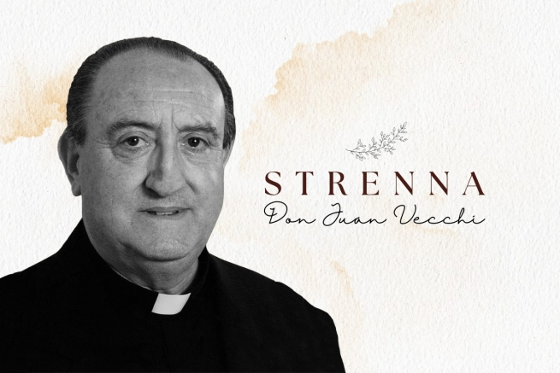
The first non-Italian Successor of Don Bosco (although the son of Italian immigrants) in the history of the Salesian Congregation was the Argentine Fr Juan Edmundo Vecchi, born in the same city where "the nurse of the poor" operated and today a saint, Artemides Zatti, SDB, with whom he was also related. Although illness did not allow him a longer term of office, it was he who guided the Salesians of Don Bosco from the old to the new millennium.
The 8th Successor of Don Bosco, having completed his initial formation between his native land and Italy, had already served for 24 years (from 1972 to 1996) in the General Council before assuming the role of Rector Major: first as Regional Councillor for Latin America, then General Councillor for Youth Ministry, then as Vicar of the Rector Major. The choice of the 24th General Chapter of 1996 to elect him to the leadership of the Salesian Society was therefore a choice of a guarantee of competence, vision and continuity.
A man of great horizons, apostolic courage and ecclesial sensitivity, he faced the illness that consumed him and marked the last years of his life first with courage and then with serene abandonment to the will of God. He was a great innovator in the field of Youth Ministry, and, coming from a missionary land himself, he continued his predecessor's "Project Africa", founded new missions and organised new projects for missionary areas, then animated the Extraordinary Missionary Expedition 2000.
At the same time, he paid great attention to Social Communication, in which he believed with real conviction: the tangible sign was the relaunching and renewal of the Salesian Bulletin in 52 editions. As well as another emblem of his term of office, the shortest in Salesian history so far, was the impulse given to lay collaborators in the mission and to the recognition and acceptance of their role.
He died in Rome on 23 January 2002, lovingly and filially assisted by the Daughters of the Sacred Hearts of Jesus and Mary – the religious congregation founded by Blessed Luigi Variara, SDB – a few weeks after the completion of his six-year mandate.
As for the strenna, at the structural level all six Strennas that Fr Vecchi was able to produce and deliver are simple and short and are characterised by the organic and stable presence of a biblical reference, in most cases, or at least an ecclesial one.
He did not leave any written commentary on the Strenna; but every year, at the Salesian Family Spirituality Days, which at the time were celebrated in Rome in January, he always made a presentation and explanation of the Strenna.
In the small body of his Strennas it is not difficult to identify ecclesiality, a sense of Church, as the dominant characteristic, the Congregation's journey in harmony with the life of the Church. So much so that his Strennas are all in line with the great Jubilee of 2000 called by Pope John Paul II: the first three are part of the path of preparation requested by the Pope himself; the one for the Holy Year takes up the central theme of the Jubilee, reconciliation; and the last two subsequent ones aim to have the seeds of grace come to fruition from that great universal event.
No mere symbolic sense of Church, then, but desired, sustained and decisive, which did not replace but rather supported and strengthened the "Salesianity" of the Strenna.
Here, then, are the six Strennas left by Rector Major Fr Vecchi:
1997: "With our gaze fixed on Jesus, the firstborn of many brothers, let us help young people to welcome him in the faith";
1998: “‘Blessed be God, the Father of our Lord Jesus Christ.’ Let us turn to him with childlike love, to be builders of fraternal solidarity with the young";
1999: "In hope we have been saved: let us rediscover with young people the presence of the Spirit in the Church and in the world, to live and work with confidence from the perspective of the kingdom";
2000: "In the name of Christ, our peace, let yourselves be reconciled";
2001: "Christ a gift for all. As a result of the jubilee let us revive our missionary spirit and solidarity";
2002: "‘Duc in altum’: lets us launch out into the deep and the open sea".

The Strennas of the Salesian Rectors Major:

Fr Chávez

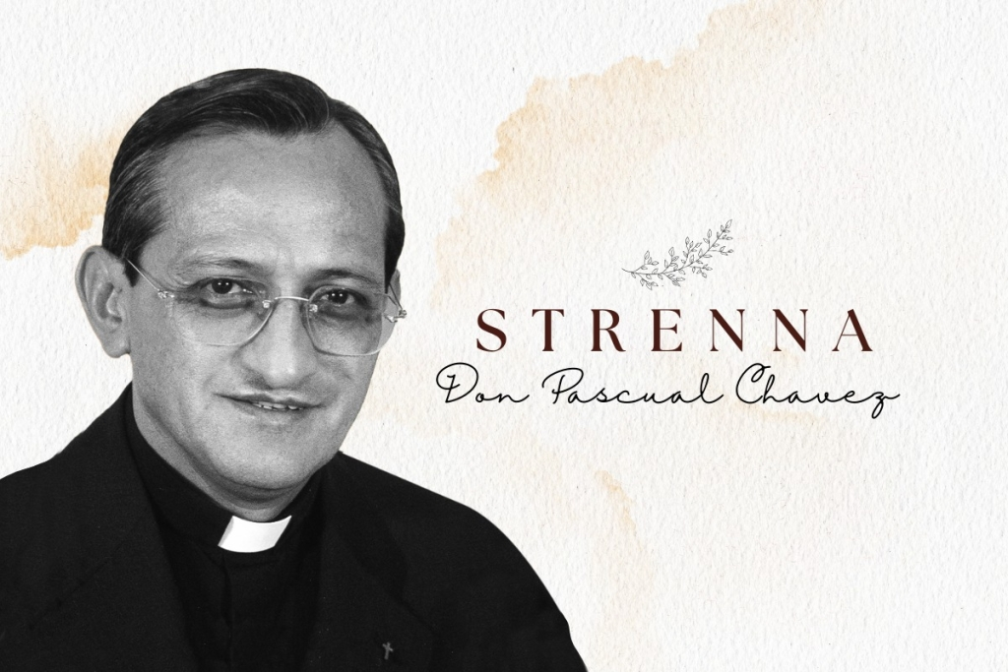
In 2002, the 25th General Chapter of the Salesian Congregation elected Mexican Fr Pascual Chávez Villanueva as Rector Major. He was the first Successor of Don Bosco of the digital age, but even if projected into modernity, the program of his term of office was still very much based on Salesian roots: it was well summarised by himself in the first message to the Salesians after his appointment, in which he invited them to “rediscover and imitate Don Bosco who served the Church and man with the same love of Christ, dedicating every moment of his life to this.”
Fr Chávez met the Sons of Don Bosco as a child, attending the Salesian school and immediately experiencing the fascination of Don Bosco. After completing all his studies of initial formation and becoming a priest in 1973, he was sent to Rome, where he obtained his licentiate in Sacred Scripture at the Biblicum in 1977, and then returned home to teach in the Theological Studentate in Guadalajara.
He also held positions as Rector, was Provincial of Guadalajara from 1989 to 1994, and Regional Councillor for the Interamerican Region, an assignment that was communicated to him, during the CG24, in 1996, in Spain where he was finishing his studies in Sacred Scripture for his doctorate, through a phone call from Fr Vecchi.
After a term as Regional Councillor, he had two as Rector Major, being reconfirmed by the GC26 in 2008.
As with the general program of his term of office, for Fr Chávez the strennas, too, “returned to Don Bosco”. “For Don Bosco, the strenna took on a specific significance: it was the gift of a suggestion which would serve as a stimulus for the formative process and spiritual growth of his youngsters and which, in addition, became a guideline for the whole community” he wrote in his first strenna in 2003. And this was the sense in which he interpreted and developed it.
At the same time, in his 12 strennas, Fr Chávez was also able to give them a new impulse, a broader and more pastoral sense, and he enhanced their dimension as an instrument of animation for the entire Salesian Family. Precisely for this reason, the Strenna is often in communion and continuity with the General Chapters: as an application and concretisation of them.
His first strennas have as their theme: the educational emergency, youth holiness, commitment to the family, the promotion of life, preference for the poor, global solidarity, the new evangelisation, ardent and active charity.
And they are often in tune with the times of the Church and the Congregation, such as the post-Jubilee, GC25, the 150th anniversary of Mamma Margaret’s death, the 40th anniversary of the conclusion of the Second Vatican Council, the 50th anniversary of Dominic Savio’s canonisation, the Centenary of Fr Rua’s death, and – as a way of preparation – the Bicentenary of the birth of Don Bosco.
As a structure, also given its preparation, the formulation almost always has a biblical or ecclesial or Salesian reference; they are simple and short, but very rich in content and in the practices to implement them. And the commentary that accompanies them often ends with a story, a fable, a wisdom anecdote, a poem, or a prayer.
In addition, since 2006, for a better interpretation and updating, the Strenna has been accompanied by one or more DVDs that serve as a guide to explore the strenna theme: a real guide to reading and studying the commentary on the Rector Major’s Strenna.
There is no shortage of strennas dedicated to young people: their education, the commitment to holiness; the family; evangelisation. And many other themes along with other major ones.
In general, it is no exaggeration to say that it is with Fr Chávez that the Strenna has acquired an important value not only because it is for all the groups of the Salesian Family scattered throughout the world, but above all because it has become a real project, a program of educational, spiritual and pastoral life for the entire Congregation with pastoral proposals, indications and practical suggestions to implement it.
Below are the 12 Strennas delivered by Fr Chávez:
2003: The home and school of communion;
2004: Let us propose wholeheartedly to all young people joy in the call to holiness;
2005: Rejuvenate the face of the Church,the Mother of our faith;
2006: Ensuring that special attention be give to the family;
2007: For a true culture of human life;
2008: Let us educate with the heart of Don Bosco;
2009: Let us commit ourselves to making the Salesian Family a vast movement of people for the salvation of the young;
2010: In imitation of Don Rua, as authentic disciples and zealous apostles, let us bring the Gospel to the young;
2011: Come and see;
2012: Let us make the young our life's mission by coming to know and imitate Don Bosco;
2013: “Rejoice in the Lord always: I say to you again, rejoice” (Phil 4: 4). Like Don Bosco the educator, let us offer the young the Gospel of joy through the pedagogy of kindness;
2014: "Da mihi animas, cetera tolle". Let us draw upon the spiritual experience of Don Bosco, in order to walk in holiness according to our specific vocation. “The glory of God and the salvation of souls.”

The Strennas of the Salesian Rectors Major:

Cardinal Fernández Artime

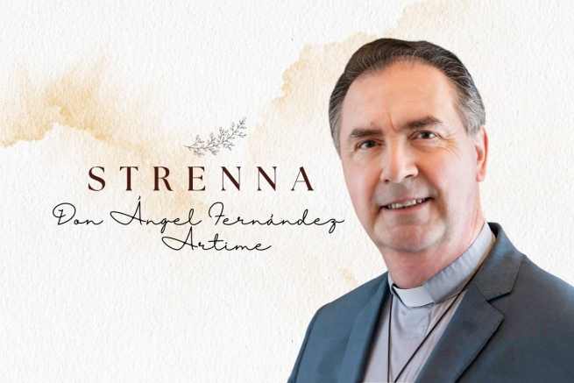

On the day of the official presentation of the final Strenna in Fr Ángel Fernández Artime’s term of office, now that he has become a Cardinal of the Holy Roman Church for a few months, ANS concludes its retrospectiveOn the day of the official presentation of the final Strenna in Fr Ángel Fernández Artime’s term of office, now that he has become a Cardinal of the Holy Roman Church for a few months, ANS concludes its retrospective look at the Strenna of Don Bosco and his ten successors so far. Therefore, if 2024 will open under the banner of the “Dream that makes you dream”, let us retrace together the journey made in the now almost 10 years under the guidance of the 10th Successor of Don Bosco.
A Spaniard from Asturias, son of fisherpeople and ready for a future as a doctor, Ángel Fernández Artime opted for the Salesian vocation after attending high school run by the Sons of Don Bosco. A Salesian since 1978, and a priest since 1987, he has held positions of responsibility since he was a young Salesian, as Rector of Works and a member of the Council of the Province of Spain-León (SLE). Already a 39-year-old Provincial, he led the SLE Province from 2000 to 2006, and then the Province of Southern Argentina, based in Buenos Aires, from 2010 to 2014.
In December 2013 he was appointed Superior of the Mary Help of Christians Province, Spain, a position that he never actually took up because on 25 March 2014, even before being installed as Provincial, he was elected by General Chapter 27, at the first ballot, as Rector Major of the Salesian Congregation.
Confirmed in this position by the 28th General Chapter, he was appointed cardinal by Pope Francis at the end of the Angelus on 9 July 2023, and created a cardinal in the ordinary public consistory in the following 30 September.
With reference to the Strenna, the current Rector Major has always considered it a constitutive element of the Salesian tradition – “a beautiful spiritual experience”, “a beautiful spiritual legacy”, he described it as early as 2014 – and a sign “of unity and communion” for the entire Salesian Family.
And this was the sense in which he proposed and shared it, aware that it “can help pastoral planning for branches and groups, (...) but its purpose is not this, it is not to become a pastoral program for the year, but rather to be a creative message of unity and communion for our entire Salesian Family, in a common goal.”
In their formulations, the strennas of the 10th Successor of Don Bosco have now made the short, concise message something stable, but one that is full of meaningful ideas, almost a condensation of keywords around which to developed proposals and paths. In addition, the bipartite structure is almost always repeated, with two sentences that complement each other and in which very often one of them is a biblical or Salesian reference.
As for the contents, it is significant to note that, since the Strenna is intended to be addressed to the entire Salesian Family, the Rector Major has often been able to count on the Major Superiors and World Leaders of the different groups of the Salesian Family in his choice of messages, in the context of the annual appointment that is the Salesian Family Consultative Council.
And the themes have ranged from the most ecclesial – as shown by the strennas on family and holiness, proposed after Pope Francis’ Apostolic Exhortations Amoris Laetitia and Gaudete et Exsultate, to the most strictly Salesian ones.
In this second group, then, two other types can also be identified: strennas linked to the significant anniversaries recorded during his term of office – such as the Bicentenary of the birth of Don Bosco (2015) and his Dream at Nine Years of Age (2024), or the fourth centenary of the death of Saint Francis de Sales (2022); and those linked to charismatic aspects, such as Salesian accompaniment or the “politics of the Our Father”.
Finally, attention to the world social scene has not been overlooked: the strenna about hope, which came after the outbreak of the Covid-19 pandemic, is a shining testimony.
Here, therefore, listed below, are the 10 strennas of Fr Ángel Fernández Artime’s term of office:
2015: “Like Don Bosco, with the young, for the young”;
2016: “With Jesus, let us adventure in the Spirit together!”;
2017: “We are family! Every home, a school of Life and Love”;
2018: “‘Sir, give me this water’ (Jn 4:15). Let us cultivate the art of listening and of accompaniment”;
2019: “‘So that my joy may be in you’ (Jn 15:11). Holiness for you too”;
2020: “‘Thy will be done on earth, as it is in heaven’ (Mt 6:10). Good Christians and upright citizens”;
2021: “Moved by hope: ‘See, I am making all things new’ (Rev 21: 5)”;
2022: "Do all through love, nothing through constraint” (St Francis de Sales);
2023: “‘As the yeast in today’s human family’. The lay dimension in the Family of Don Bosco
2024: ‘The dream that makes you dream’. A heart that transforms ‘wolves’ into ‘lambs’”.

