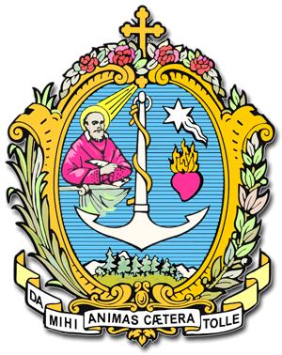
DIREZIONE GENERALE OPERE DON BOSCO
Via della Pisana 1111 - 00163 Roma

Il Rettor Maggiore

A GREETING FOR THE FIRST MEETING OF TRANSLATORS OF SALESIAN TEXTS IN THE EAST ASIA-OCEANIA REGION
(Vietnam, 9-11 October 2014)

My dear Confreres,

Frs Václav Klement and Filiberto González, both of them General Councillors, have kept me informed of their respective services to the Congregation, and have let me know that shortly a meeting of translators of Salesian texts will take place in the East Asia-Oceania Region.

I have to tell you sincerely, dear confreres, that this is one of the best news I have received, and I applaud it and support it with all my heart. You may count on my encouragement, my congratulations, and I ask you, please, to do everything possible to see that this service really comes to fruition. It has been a strongly felt need, and for quite some time throughout the Congregation, at the General Administration, in the Regions and also in each of the Provinces.

In the study that GC27 made of the state of the Congregation, the lack of qualified translation and timely translations were noted. If there should ever be a lack of translators it will be very difficult to communicate and pass on the charism, animation and government of the Congregation in general, along with animation of each of the confreres.

Faced with this situation, dear confreres, I would like to strongly emphasise that this service is much more than just an assignment, much more than a job to do. We are really dealing with a ministry here, a true service of quality, a very important task that means a lot and has many implications for the life of the Congregation.

In the brief time that has passed since the 27th General Chapter concluded, I have already expressed my belief on various occasions concerning the importance that translations have and that translators especially have for the Congregation, keeping in mind the important objective that translation of family and official letters needs to happen in as many languages as possible, so their contents can be communicated in the language that confreres speak.

This is precisely why I would like to highlight the importance of this first meeting of the kind in the Congregation's history for EAO, where twenty or so SDB and Lay Mission Partner translators from at least six Provinces in the Region will meet. So here are my hopes for you:

1. Thank you for this valuable, difficult and delicate ministry of translation in the service of the Salesian charism, especially in this Global Village and a time of globalisation, given that as a Salesian Congregation we find ourselves in 132 countries, speaking a hundred or more mother tongues, but at the same time we share the gift of the Holy Spirit in shaping the Salesian charism. It becomes a fundamental condition for the growth and inculturation of this charism in the various cultures.

2. I would like to help Provincials to appreciate, value and strengthen this ministry, encouraging the formation of young confreres in the translation field (facilitating their being sent abroad, both to Italy and in English-speaking areas), making strides in the direction of interculturalism and multiculturalism in formation. I have no doubt these features are already there, and will be even more the case in our Congregation's future.

3. In the specific circumstances of the East Asia-Oceania Region, amongst the ten or so Provinces, almost half (China, Japan, Korea, Thailand, Vietnam and East Timor-Indonesia) have particular need of this service to reinforce communion with the World Community of our Congregation (C. 59),and also to have access to Salesian sources.

4. In a practical connection I would like to encourage you to familiarise yourselves with the development of tools which facilitate consistent translation (the database of Salesian terminology – Salesian Termbase-; various computer programs specifically for translators, teamwork at Province and regional level so as to have common criteria for translations (communication via ‘Salesian Digital Library’ found on the Congregation's website: http://sdl.sdb.org/cgi-bin/library, etc...).

5. And in time, perhaps, it may be possible to create a team and work together with our Salesian Sisters and other Groups in the Salesian Family in nearby Provinces (THA, VIE, MYM)... Undoubtedly a first step will be to share this initiative.

Let me conclude, dear Salesian confreres and lay people involved in this passionate project, by thanking you not only for your availability for this meeting but also for making it happen, such is your commitment and mine, along with the General Council's.

I would not like to overlook, even though in general and anonymous terms, the many confreres who, since the beginning of our Congregation, have dedicated much of their lives to the translation of our magisterium (our teaching and documentation) in the life and development of the Congregation. We are encouraged by their witness and by recalling them now. I also thank the group of confreres, some of them in your Region, who are spending so many hours a day at this very moment, translating, with great generosity and sacrifice. Thank you with all my heart.

Nothing more for now. No doubt the Lord and Don Bosco will also be blessing this enterprise.

With fond regards,

From Rome, 15 August 2014, Solemnity of the Assumption.

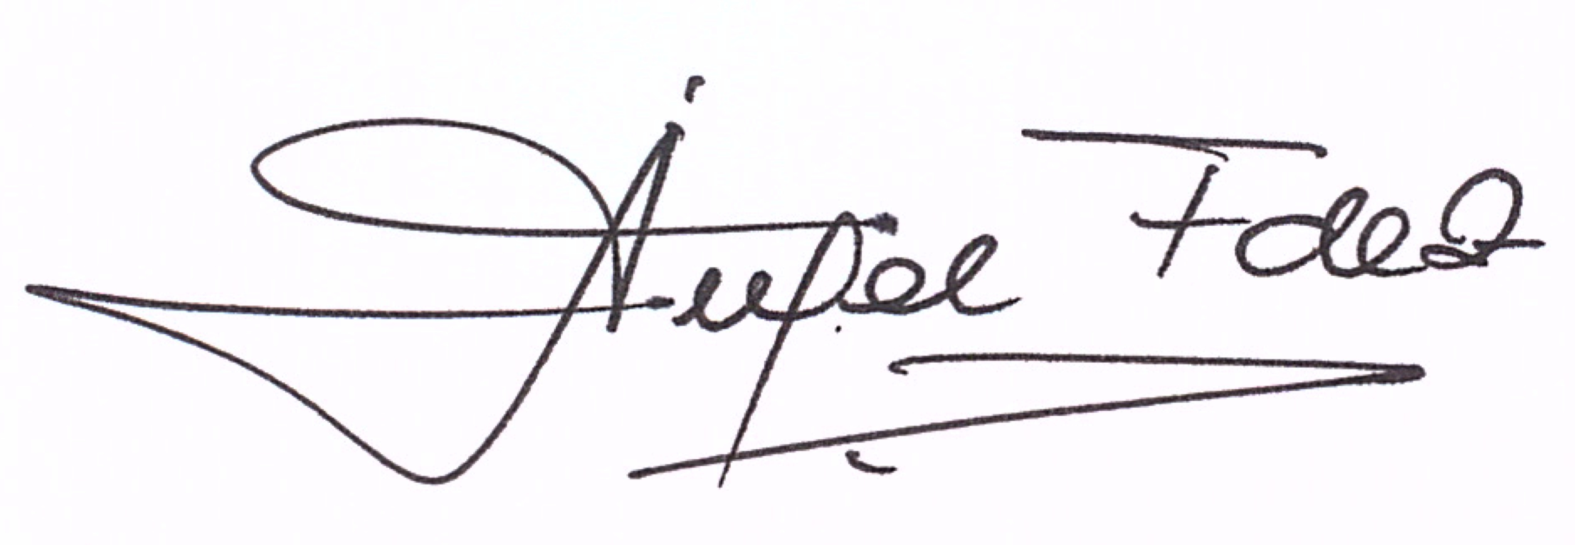

P. Ángel Fernández A.,SDB
Rector Major

