The Message of the Rector Major
Don Ángel Fernández Artime

STEPHAN SÁNDOR COMES HOME
«A series of miraculous coincidences surrounded and enhanced
the solemn celebration for the blessing of the relics of Blessed Stephen Sandor, who had been martyred for “being a Salesian.”»

Cordial greetings, my friends, readers of the Salesian Bulletin and friends of Don Bosco's charism.

I know that speaking of anything that refers to armed conflicts and totalitarian regimes of one or another ideological ilk is always a delicate matter because it touches people in many different ways. There is “family heritage” in terms of political positions and then there is the cultural environment in which one lives. Although I am aware of this, history cannot be changed. It can be rewritten to fall short of the truth, but that does not change what happened. In the case I wish to relate, it is the history of a young Salesian of Don Bosco, a Brother, Stephan Sándor.

Stephan Sándor is not a young man whom I met on one of my trips but he was a young Salesian martyred in Hungary and now beatified. At the age of thrity-nine, Stephan was sentenced to death and executed during the dark years of communist rule in Hungary. Of what crime was he accused? He would gather boys for sports, youth activities, and to teach a trade. This was considered high treason to the regime.

Yet Stephan's story is very special: in terms of his conviction, how he saved the lives of six young people who were arrested with him, his execution, his burial in a common and unmarked grave, and how his body was found seventy years later with the help of Martin, a former student along with three professionals who are experts in history and DNA evidence. This discovery made it possible for me to go to Budapest, Hungary, on June 4, 2022, to the Clarisseum to celebrate the Blessed's return home to the same place from which he had been taken to the gallows. Additionally, after seventy years, the land and the house from which they were once expelled and into which they were forbidden to enter ever again has now been returned to the Salesians of Don Bosco.
The Clarisseum reopened
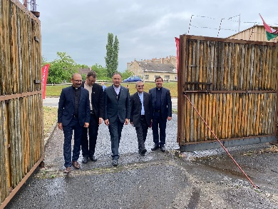
The photograph in which you see us entering from an outside door shows us making a step that no one could have made in the last seventy years, until today. I am telling this because I sincerely believe that despite the difficulties that we are seeing, even at this present moment in European and world history, God continues to have the last word, the definitive one, about life and death. So, it has been with the young Salesian, Br. Stephan Sándor.
« I owe him my life »
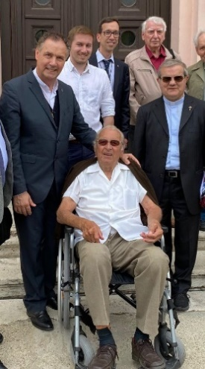
Stephan prevented six young people from being executed with him. In one of the photographs, you see me with a man sitting in a wheelchair. His wife could not come because she was very ill. He was one of the six young people who, at the age of 22, were arrested along with Stephan for being considered traitors to the regime. After a very harsh interrogation with torture, the young Salesian managed to talk to the six young people at one point and asked them to blame him for whatever they were being accused of by the communists. Although the young people resisted, he told them that because of both the friendship that united them and their faith in Jesus, they had to do so to save their lives. And that is what happened—that is what this former student, a former youth animator at the Clarisseum, told me. Indeed, Stephan was sentenced to death, and the young men were sentenced to eight years in prison. Fortunately, our friend told me, three years later, the communist regime fell in Hungary, and his sentence was repealed.

The DNA of a postage stamp
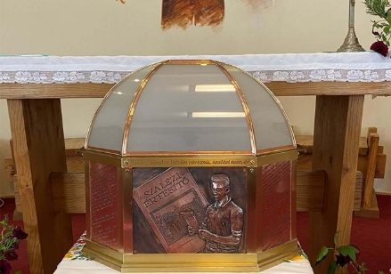
For seventy years, Br. Stephan’s body lay in unknown whereabouts. He had been executed and buried in a common grave with five others, in a forest on the outskirts of Budapest, without any indication or name that could give clues as regards who or what was there. The burial took place at night without leaving any trace—precisely what those who had executed him intended. For seventy years, the conviction was held that it would be impossible to find his remains. Yet the tenacity of a young ex-student coupled with the experience and great knowledge of an expert on the history of those years in Budapest (who went so far as to say where she sensed they might be buried from what was known of many other burials from that time), caused the mortal remains of six executed men to be found a few months ago. It seemed incredible that they had found just the remains of six people. It remained to be seen if one of them could be Blessed Stephan.
The DNA of a stamp—it was the DNA that was collected from a letter written by Stephan and from another letter with a stamp put on it by his brother (who spent his whole life looking for Stephan without being able to see it because he died three years ago) that allowed two great professionals to identify many of Stephan's mortal remains, remains now collected in that delicate casket that we see. It was my great joy to meet and greet these experts in DNA recognition techniques.
On account of the above and in many other details, what we have experienced is unique. I can testify to the emotion and even shock of many people at Mass that morning. Sharing in it throughout that day was indescribable. I can testify to the emotion of the now old man who was able to lay his hand on the casket of his Salesian-educator, friend, and martyr who saved his and his peers’ lives, who sacrificed himself to free them from the same end. I can testify from what I have experienced that this is not a coincidence; it's much more than that. It is also the presence of God in the events of history (along with human freedom). That is why I can affirm what I said at the beginning: Blessed Stephan Sàndor returns home. And the Salesians today, with the young people who are there and those who will come, also return home, to his house, to the Clarisseum in Budapest, Hungary.

