THE MESSAGE OF THE RECTOR MAJOR
DON ÁNGEL FERNÁNDEZ ARTIME

THE POLITICS OF THE OUR FATHER

Fruit of the Salesian Family Spirituality Days: a beautiful “Our Father” to live every moment of each day

Dear Readers of the Salesian Bulletin,

I greet you during this Lenten Season from Valdocco-Turin where we Salesians of Don Bosco are celebrating our General Chapter XXVIII – right here where we were born "Salesian" for it was here that Don Bosco established his mission with his first boys. It was also here that he founded the first Salesian Oratory together with his mother (that is how I like to say it) – she who is rightfully called the mother of those “homeless of the moment”.

During these past six years, I have chosen to share with you many times through this greeting some experience I had as I traveled throughout the Salesian world.

Today I offer you something simple and different - something which I trust will interest you or, at least, “connect us all” for one minute. I am speaking of a fruit of those beautiful days of reflection, our celebration of the Salesian Family Spirituality Days XXXVIII: the prayer of the "Our Father" with each phrase “translated into ‘Salesian’” and annotated with a Salesian action so as to make it concrete for today, an expression of our Salesian commitment.

I propose that you read it and see if there is at least one phrase that “speaks to you” and that you can dwell on, if you think it is a good thing to do.

I can assure you, that as a Salesian Family and as friends of Don Bosco in the Salesian world, we really seek to translate the Our Father into our everyday life each day.

This is our prayer

You are Our Father! A Father of infinite mercy; not a small or trivial presence, but Your presence, with the infinite power of holiness and love that patiently educates His children.

Thy Kingdom come! The very Kingdom that Jesus has begun in this world, fulfilling Your mission. We welcome without reservation what You intend to do for us and for the young.
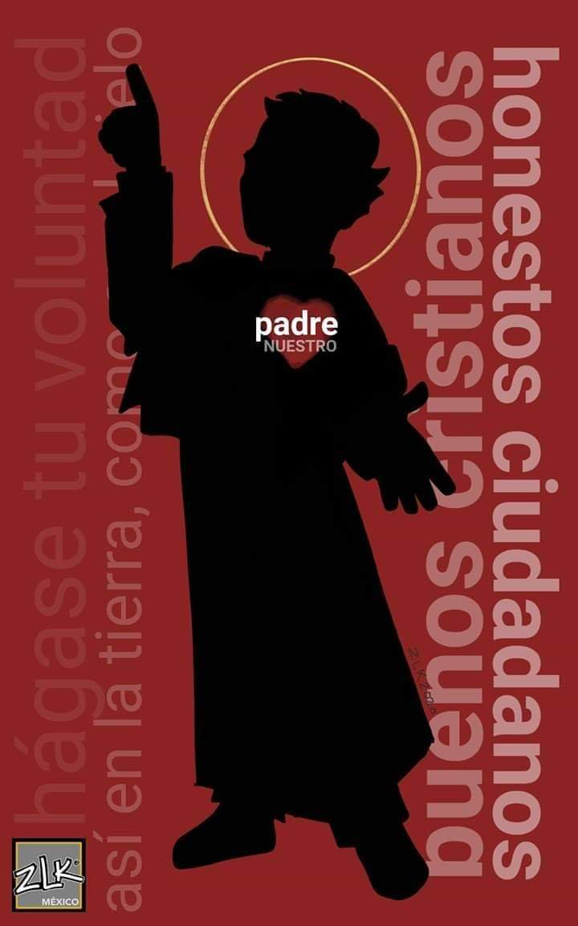
Thy will be done, by living the dynamics of Your Kingdom, the dynamics of the Spirit of Pentecost that prompts us to be constantly in mission so as to give birth to signs of freedom and reconciliation among Your children and our brothers and sisters.

On earth as it is in heaven. Together with the young, like Don Bosco, we proclaim our YES to the fullness of life for every young person and for all young people, so that they may be citizens and Christians fully committed here on earth, and forever happy inhabitants of heaven.

Give us today our daily bread; the bread needed for life, so that the Kingdom of God may be manifested in Your providential care for our needs and so that we may also see and confess that the work of our hands is actually the fruit of Your grace. Let us be moved and energized not by greed to possess, but by sharing with the poor.

Forgive us our trespasses, while we do our best on our side in forgiving our brothers and sisters. Help us to put the Preventive System into practice in patience, in magnanimity, in coming lovingly to the rescue of young people who have made mistakes; in exemplary, joyful, and cheerful self-giving; in faithful and resilient dedication to our daily commitments.

Lead us not into temptation. The temptation to look back, to look in the wrong direction, to oppose the Spirit, to blush because of You, our Master, when we are exposed to the judging court of men, of fashions, of ideologies; when we are allured by the flattery of the powerful; when we are challenged by our conscience.

Deliver us from evil. Let us never doubt that, in spite of everything, You are the only One in control of the history of the world; let us never doubt that it is You indeed who wants us to be fully committed as educators, in order to set young people free from despair and from all their prisons.

Deliver us from the evil of forever moving away from your face. For this, we wholeheartedly pray, send us the Holy Spirit, so that He may heal the wounds of body, heart, and spirit and awaken in us an ever new hope in joyfully carrying out the mission that our father Don Bosco has opened before us.

AMEN!

I wish you every good and happiness in the Name of the Lord.
Don Angel

