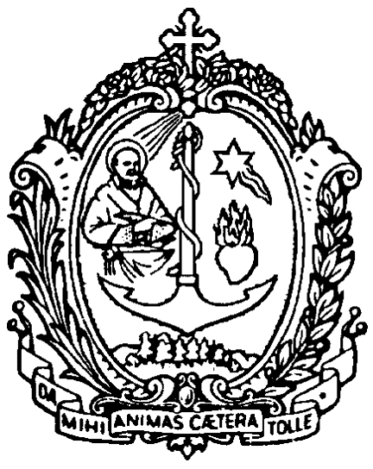
DIREZIONE GENERALE OPERE DON BOSCO
Via della Pisana 1111 - 00163 Roma

The Rector Major

Rome 8 June 2013

Dear confreres,

For the 60th anniversary of the martyrdom of our confrere, Salesian Brother Stephen Sándor (26 October 1914 - 8 June 1953), and given his Beatification soon to take place on 19 October next in Budapest, Hungary, I would like to address this message to you so that throughout the entire Congregation we can appreciate the gift given us in this Year of Faith and on our way to the Bicentenary of the birth of our father and founder, Don Bosco. It is a grace for us and the entire Salesian family.

Stephen Sándor was a deeply religious person from birth until death, and in every circumstance of his life he responded consistently and with dignity to the demands of his Salesian vocation. This is how he spent his aspirantate and initial formation, his time at the printing press, and as a leader at the oratory and in the liturgy, while he was living clandestinely and in prison, right up until his death. From the time he was a young man he wanted to consecrate himself to the service of God and his fellows generously, in education of the young following Don Bosco's spirit and he nurtured a spirit of courage and fidelity to God and his brethren that enabled him, at a time of trial, to resist, firstly in circumstances of conflict, and then in the supreme test where he gave his life.

I would like to highlight the witness to the radical nature of the Gospel which this confrere gave, something that becomes particularly eloquent given the upcoming General Chapter. When we draw up an account of Stephen Sándor's life we see a real and profound journey of faith, which began in his childhood and early youth and, strengthened by his Salesian religious profession was then consolidated by his exemplary life as a Salesian Brother. In particular we note his genuine religious consecration enlivened by the spirit of Don Bosco, and keen and fervent zeal for the salvation of souls, especially of the young. Difficult times like his period of military service and his wartime experience did not damage the young Brother's moral and religious integrity. And it was on this basis that Stephen Sándor would undergo martyrdom without hesitation or second thought.

Stephen Sándor's Beatification commits the Congregation to fostering the vocation of the Salesian Brother, by recognising his exemplary testimony and as a community calling on his intercession for this intention. As a Salesian layman, he succeeded in giving good example to priests as well by his activity amidst the young and through his example of religious life. He is a model for consecrated youth for the way he faced up to difficulties and persecution without compromise. The causes he gave himself to, his sanctification of Christian work, his love for God's house and for the education of youth, remain the fundamental mission of the Church and of our Congregation. With this in mind I invite you to take up what Fr Vecchi wrote for the Beatification of Artemides Zatti (AGC 377). His reflections and guidelines are still relevant and encouraging today. You can also read what the 26th General Chapter said about the unique Salesian consecrated vocation in its two forms.

As an exemplary educator of the young, especially apprentices and young workers, and as a leader at the oratory and of youth groups, he gives us example and encouragement in proclaiming to young people the Gospel of joy through a pedagogy of kindness. In this second year of preparation for the bicentenary it encourages us in zeal and enthusiasm for our mission amongst the young in popular settings where young people are beginning work or finding that work leads to problems where they are easily exposed to injustice.

While we give thanks to God for this new gift that confirms and seals Don Bosco's Salesian charism with blood, I would like to invite every province to plan some gathering for reflection and to celebrate the gift of the Beatification of this confrere, Brother and Martyr and to renew our commitment to our vocation, supported by his example and intercession.

I also invite you to read his life which will soon be published and offer it to young people and those in formation, especially those in early formation where they are still discerning which form of the Salesian vocation to follow. Blessed Artemides Zatti, and our Martyr Stephen Sándor as well as the Venerable Simon Srugi are an especially attractive trio offering us a varied and rich profile of the Salesian brother.

With all my affection, in Don Bosco

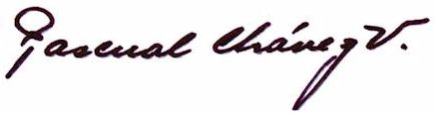
Fr Pascual Chávez Villanueva
Rector Major

