 | Nouvelles Salésiennes  Salesian News  MARCH 2013 MARS No.163  Bulletin mensuel électronique  sdbsem@videotron.ca

TORONTO-HAMILTON, ON.

Before Lent and During Lent
In true Salesian style the Toronto/Hamilton community celebrates, prays, evaluates, ministers and offers hospitality, each at the proper time.

BL – Before Lent
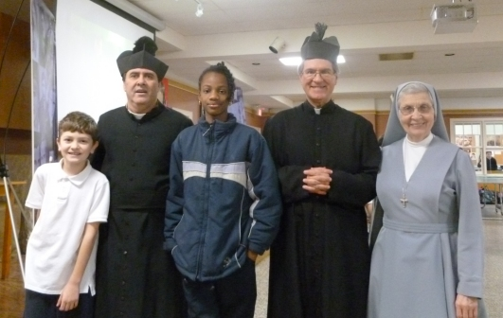
Don Bosco ritorna:Domenico Savio, Bosco, Domenica Savio, Bosco, Maria Mazzarello

Salesian Family and Salesian Youth Movement celebrations of St. John Bosco continue into the first days of February. Fr. John Puntino, Fr. Mike Pace and a group of young adults participate in a Mass and reception at FMA Don Bosco Centre in Markham. Fr. Tom Rosica, CEO of Salt & Light Catholic Media presides and preaches. Then, there even seems to have been a sighting of not one but two Don Bosco’s during Savio Club.
“Before Lent” also features occasions that include good dining. Fr. Joseph Ho’s niece and family treat the confreres to fine Chinese cuisine for the beginning of the Chinese New Year. St. Benedict Parish girls preparing for their Confirmation and their mothers enjoy a pancake breakfast while nourishing their spirits listening to testimonies of women living an adult faith life. A few Saturdays later, though after Lent begins, sons and fathers have their pancake breakfast. Knights of Columbus anticipate St. Valentine’s Day with a dinner dance on the Saturday before Ash Wednesday. Shrove Tuesday rounds off BL with a pancake dinner organized by the Squires.
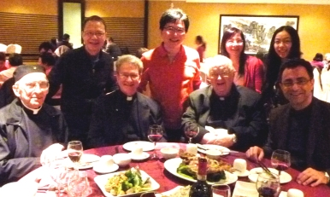
Confreres celebrating Chinese New Year with Winnie Wong, niece of Fr. Joseph Ho, and her family
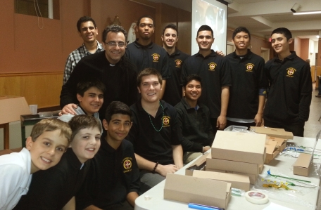
Fr. Mike Pace, Squires chaplain, and Squires at Shrove Tuesday’s pancake dinner

The community welcomes to Toronto Fr. John Nazzaro, Director of Salesian Boys and Girls Club in East Boston, where Bro. Bernie Dubé is currently stationed. Fr. John manages to preach the quarterly day of recollection before the approach of winter weather forces his early return home. Bad weather also forces the cancellation of the young adult organized holy hour and social, called The Visitation, which is becoming a monthly ministry highlight at St. Benedict.
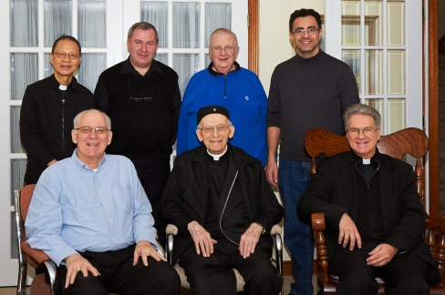
Provincial Visitation:Etobicoke and Hamilton confreres with Fr. Provincial

DL – During Lent
On Thursday after Ash Wednesday Fr. Tom Dunne, Provincial, arrives in Toronto for the annual Provincial Visitation. Of importance this year is the review of the community’s implementation of the recommendations from last year’s Extraordinary Visitation.
Lent, of course, is confession season. All confreres are kept busy attending to school reconciliation days, to longer lines during scheduled penance times in the parishes and to assisting with confessions at Salesian Leadership Retreats (SLR) organized from two Catholic District school systems.
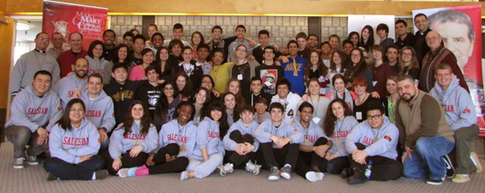
SLR with Frs. Mike Pace, George Harkins and Abraham Feliciano

Toronto Catholic District’s SLR, in particular, attracts the participation of Fr. Abraham Feliciano, Province Councillor for Youth Ministry, and of Fr. George Harkins and four students from Seminaire Salésian in Sherbrooke.
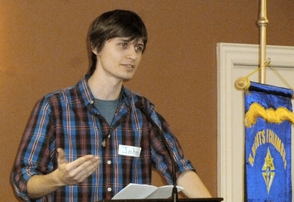
Don Bosco Residence provides an ideal setting for the SLR adult and youth team meetings, for overnights for Fr. George and the young men SLR participants and, earlier in the month, for two young men from the World Youth Day pilgrimage being organized by Salesian Sisters. A happy first for the residence is the hosting of Don Bosco Centre, Markham’s FMA community for a quarterly day of recollection.
Mr. John Rugosi giving a witness talk at Sons & Fathers Confirmation breakfast

February 28, 2013 will remain an important date in Church history with the resignation of His Holiness Pope Benedict XVI. Fr. Mike Pace exercises Salesian social communications ministry in serving as a commentator on Salt & Light Catholic Media’s live broadcast of the Pope’s last general audience. Then, he gives an interview on CP24 TV on the Holy Father’s legacy. (J.P.)
++++++++++++++++++++++

MONTREAL The feast of St.John Bosco was celebrated on Feb. 2-3. The evening Mass of Feb. 2 was given more solemnity with the singing of the 2 joint choirs, English and Italian, and the concelebration of the priests available. Followed a banquet at the Chateaubriand for some 400 persons, several families with their children in an atmosphere of great joy. Even if the liturgy of the following day was that of Sunday, the saintly Founder was celebrated at every Mass.

At the beginning of the month, we started the cleaning of the interior walls of the church, a work that continued throughout the month at the times when no religious function was held, thus giving the sacred place a clean look.

On February 11th, feast of Our Lady of Lourdes, came the sensational and unexpected news of the renunciation of Pope Benedict XVI to the See of Peter as bishop of Rome: a humble and courageous act, taken after much reflection and prayer. He felt that his physical energies had diminished considerably in the past few months, rendering the accomplishment of his mission as pastor of the Universal Church very difficult.

In mid-February, our director, Fr Richard, after having celebrated Mass at the Salesian Sisters’ Savio Convent, slipped down the exterior stairs and broke the left femur. Taken to the hospital by ambulance, he was operated on a couple of days later. After some 15 days under observation, he was transferred to a rehabilitation centre for therapy. He should be back at the rectory in a couple of weeks.

During these days, some 200 children who are preparing for First Communion received their first sacrament of Reconciliation. It was edifying to see that many parents who took their child to church also approached the sacrament.

On a recent Sunday, some Sisters of the Congregation of Our Lady of Africa, founded by Cardinal Lavigerie, participated at all the Masses to share with the parishioners the objectives of their Congregation and their apostolic activities in African lands. (E.T.)

=====================
SHERBROOKE. Les jours filent et ne se ressemblent pas. C’est que le temps, c’est la vie, et la vie, c’est quelque chose de dynamique. Le mouvement en est un élément essentiel. C’est quand même à présent un temps de pause; on est en relâche scolaire. Le beau temps est de la partie : un bonheur pour ceux qui pratiquent les sports extérieurs. On sent que Dame Nature oscille entre l’hiver et le printemps. Bientôt- d’ici quelques jours- les érables commenceront à donner leur sève. Et ce sont d’autres sportifs qui regardent l’avenir avec hâte.
On ressent toujours l’absence de notre Père Paul et en communauté et à l’école. Même discret comme il était, un grand vide se fait ressentir. Le passage du temps fait disparaître certaines dimensions d’une vie, mais jamais entièrement. Si c’était le cas, il n’y aurait rien de valeur dont se souvenir.

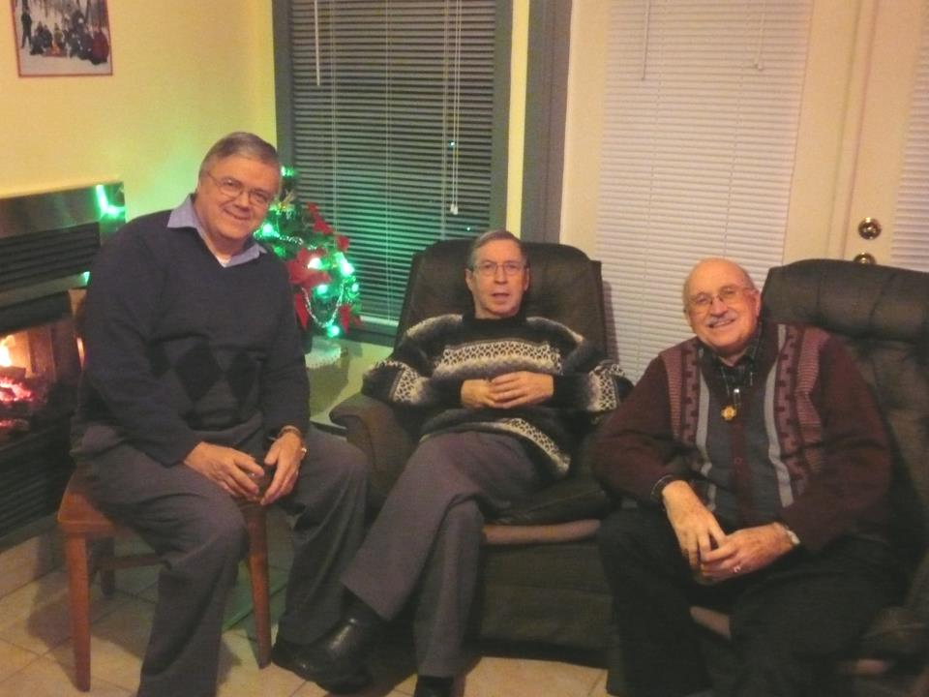
Camp Savio, le 4/01 : la dernière photo prise du p. Paul Cossette/Fr. Paul’s last photo

Le grand événement du mois fut l’annonce le 11 février par le Pape Benoit XVI de sa renonciation au Pontificat, renonciation qui prendrait effet le 28 du mois. Nous avons regardé avec émotion les images de son départ du Vatican vers Castelgandolfo où il séjournera pendant deux mois avant de retourner au Vatican, non plus dans le Palais Apostolique où résidera son successeur, mais dans un ancien monastère dans les jardins du Vatican à l’ombre de la basilique St-Pierre, « caché, comme il l’a dit lui-même, aux yeux du monde, poursuivant ma mission auprès de l’Église universelle dans la prière et la réflexion. » Il a choisi le lieu le plus propice pour passer sa retraite de prière, d’étude, de lecture et d’écriture : calme absolu- seul le murmure des fontaines environnantes est perceptible- flore et faune abondantes. Et l’Église est dans l’attente d’un nouveau pasteur.
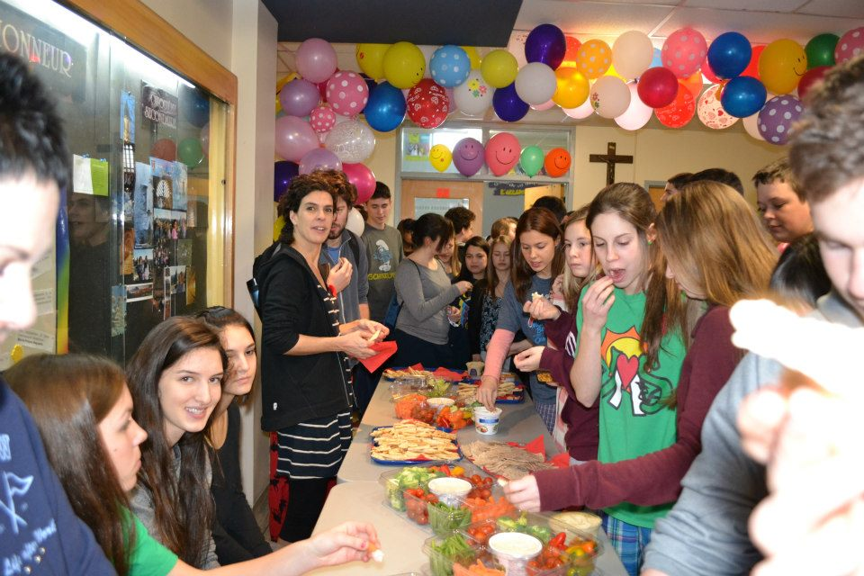
La semaine du Mieux-Vivre
La Semaine du mieux-vivre fut célébrée cette année du 11 au 15 février sous le thème, Garde ton cœur d’enfant, et fut accompagnée d’une multitude d’activités. Le dernier jour, c’était le carnaval d’hiver. Ce n’est pas par hasard que la St-Valentin se retrouve à l’intérieur de cette semaine. Cette activité, parmi d’autres, donne à l’école une couleur particulière et veut inculquer certaines valeurs éducatives.
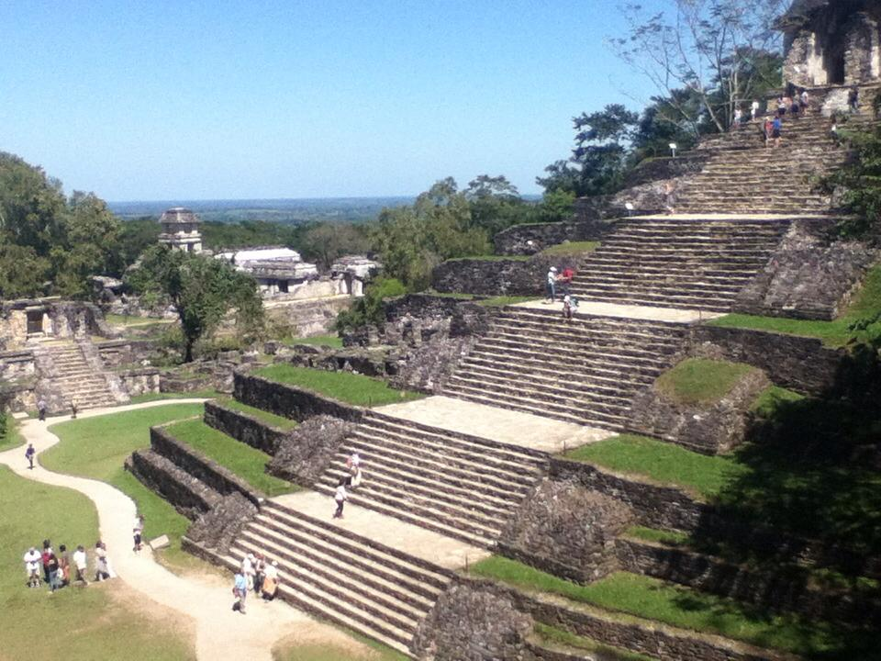
Ruta Maya : Palenque, l’un des sites mayas les plus appréciés par nos voyageurs.

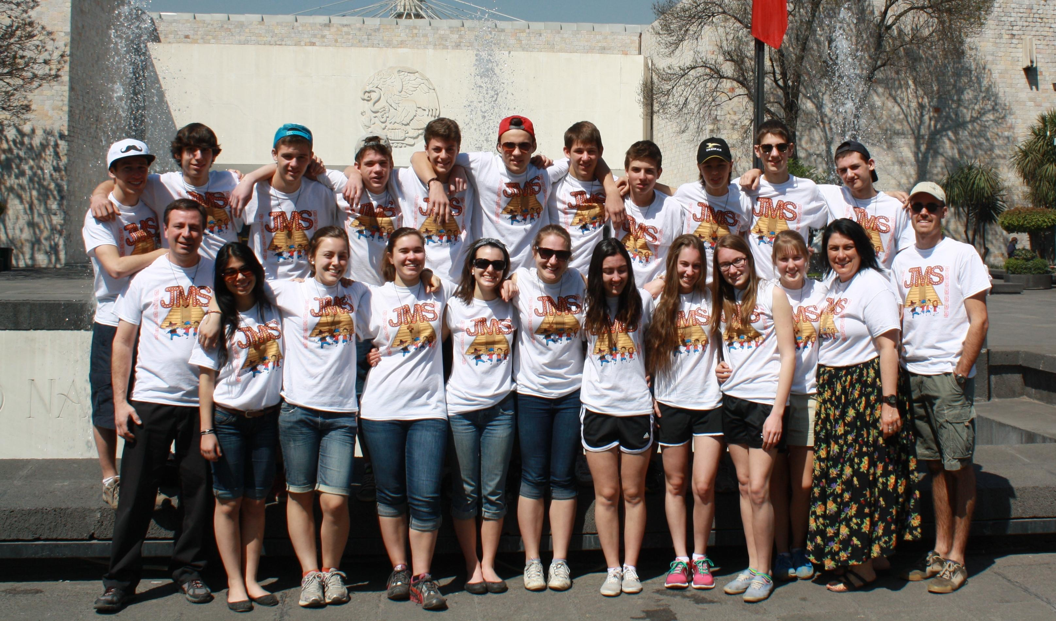
Trois grands voyages sont en cours. (1) Expédition au Pérou (21 février-8 mars). Accompagnés de 2 enseignants, 11 jeunes de 4e et 5e sec. s’aventurent sur les routes du Pérou à la découverte des vestiges Incas. Avec Lima comme point de départ, ils font la connaissance de la ville sacrée de Cusco et des environs pour se rendre ensuite au Machu et au Wayna Picchu. (2) Voyage culturel Ruta Maya (24 février -11mars). Des élèves de 2e et 3e sec. vivent au rythme du Mexique durant cette expédition qui les amène sur les routes de la péninsule du Yucatan. Ils séjournent aussi dans des familles et suivent les pistes des pyramides mayas. (3) Voyage humanitaire des JMS (1-16 mars).Une vingtaine de jeunes de la 4e sec., nos Jeunes Missionnaires du Salésien se retrouvent à côtoyer des jeunes mexicains du refuge salésien de Santa Catarina, Mexico City. Ils vivent des émotions intenses et chaleureuses auprès de ces enfants égratignés par la vie.
Quatre jeunes de la 5e sec. accompagnés du p. George, ont participé avec plusieurs dizaines d’autres jeunes des écoles de la Ville Reine lors d’un weekend au SLR (Salesian Leadership Retreat) à Toronto. Ils disent avoir vécu une expérience très enrichissante. Et parlant de retraite, les membres de notre communauté ont aussi vécu un 24h –moins flamboyant!- de recueillement silencieux à l’Abbaye St-Benoit-du-Lac. Nous avons pris le repas du midi au réfectoire des moines, mais sans aucune conversation, puisqu’une lecture se fait pendant tout le repas. Ce jour-là c’était une lecture du dernier livre de Benoit XVI, L’Enfance de Jésus. Un séjour très salutaire!
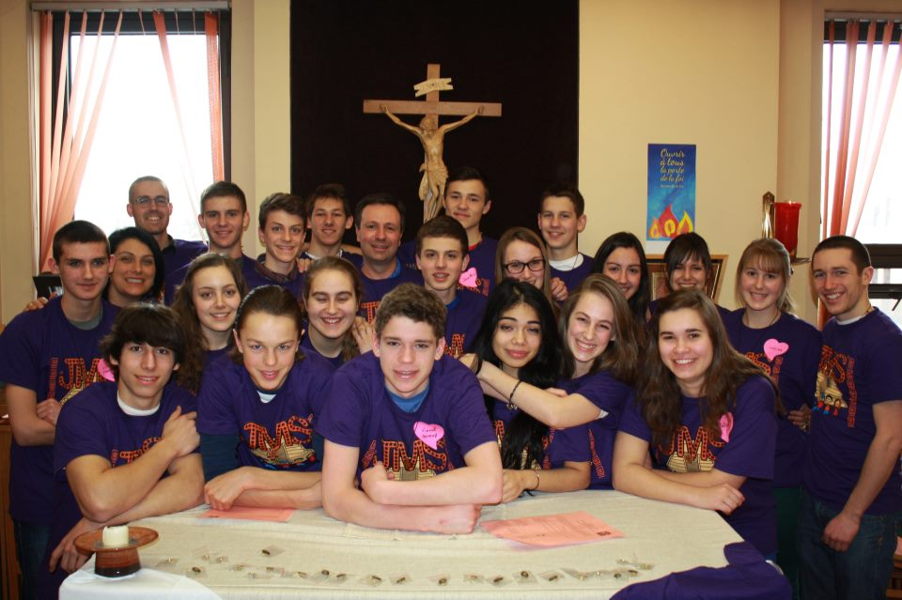
Les JMS : chapelle du Salésien, envoi en mission

JMS : sommes arrivés à Santa Catarina, Mexico City

Ce dernier weekend, le p. George servait de traducteur pour CBC aux Championnats des Universités Canadiennes à l’Université de Sherbrooke. Il s’agissait de la discipline volleyball féminin.
Comme mentionné ci-dessus, le mois s’est terminé par ces impressionnantes images diffusées aux cinq continents de la fin du pontificat de Benoit XVI et de sa retraite dans les collines de Castelgandolfo, là où « il y a, disait-il lui-même à l’été 2012, la montagne, le lac et la mer. » (R.T.)
+++++++++++++++++++++++++++

SURREY. B.C. Although February seemed like a short month, it certainly was a busy, active and wet month here on the West coast. Many meetings and Lenten preparations highlighted the month with the introduction of the Friday evening Stations of the Cross throughout this penitential season.

Fr. Dominic Tran, the Province Vocation Director, joined us for two weekends 8th thru 10th and again on the 15th thru 17th leading the “Come and See Weekend” at our Rosemary Heights Retreat Centre here in Surrey. He also spoke at our main Masses on both Saturday and Sunday.

Ash Wednesday had all of us on deck for the distribution of ashes at the four Masses that were scheduled and packed to overflowing. The choirs added to the solemnity of the occasion. The 9:30 am Mass on the 3rd held the enrolment ceremony for our Confirmandi, whereas on the 10th it was for those making their First Holy Communion this coming May.

“One Faith One Body One Mission” was the title of the Archdiocese of Vancouver’s Conference held at the Vancouver Convention Centre. The main speaker was Sr. Miriam James Heidland, from the Society of Our Lady of the Most Holy Trinity. She was raised in Woodland, WA, and is a graduate of the University of Nevada, Reno, where she played volleyball on a scholarship and majored in Communications. It was a full day concluding with the Mass with Archbishop J. Michael Miller.

Our Parish Lenten endeavour this year, under the title, “The Shy Catholic Conference” began on the 18^{th.} This series of three successive Mondays from 7- 9 pm was presented by Mr Graham Osborne, a renowned lecturer in the Vancouver area. He explained our Catholic faith using Scripture, Tradition, and the Church Fathers.

Fund raising events like Pancake Breakfasts sponsored by the Praise Team, and Filipino “Tasty Treats” sponsored by the Youth for Christ after all the Sunday Masses certainly helped to make our church porticos a busy, Grand Central Station, busy bee hive of activity.

The TAX CLINIC at OLGC got underway on the 23rd and will run every Saturday and Sunday from 1 – 5 pm until April 28th. This is to assist new immigrants, disabled seniors, students and low-income families in preparing and filing their income tax returns.

There was a Parish Assembly, Finance Council, and numerous other meetings from the Salesian Cooperators all the way to the Priests’ Deanery Meeting along with our Salesian Day of Recollection held at our neighbouring Ukrainian Catholic Church of the Holy Eucharist. - Fr. John celebrated his 48th Anniversary of Ordination. Kindly keep his health in your generous prayers as he suffered a setback lately with back pain muscle spasms that kept him off his feet for a few days.

Needless to say, but our Spring flowers are already making their way above ground while a good majority of the country is still coping with “Old Man Winter” and snow storms. - God’s Little People have a very simple Lenten Banner on our Lector’s pulpit decorated with a very plain symbol. Each weekend that symbol is embellished with another more decorative sign inviting our youngsters to take notice and participate in the true meaning of Lent.

The last day of the month, throughout the Archdiocese of Vancouver, all parishes had a special Thanksgiving Mass for our Holy Father. Fr. Mario gave a wonderful homily on the papacy. He also remembered our very first Salesian pastor, Fr. David Zunino, who actually died on Feb. 29^{th.} 1980 here in the rectory.

In conclusion we are praying for Our Holy Father Emeritus, and for the Holy Spirit’s inspiration in assisting the cardinals in Rome in the election of our next Supreme Pontiff. (J.H.)

++++++++++++++++++

JOYEUX ANNIVERSAIRE
HAPPY ANNIVERSARY

Naissance
Dominique Britchu : 1/03
Romano Venturelli : 7/03
Bernard Dubé : 19/03

Religious Profession

Mario Villaraza : 1/04

Ordination Sacerdotale

Roméo Trottier : 5/03
Georges Parent: 21/03
Frank Kelly : 3/04
Joseph Ho : 3/04

Liturgical Feasts

March 19: St. Joseph, patron of the Church,
Canada and the Salesian Society.

31 MARS: PÂQUES

==========================

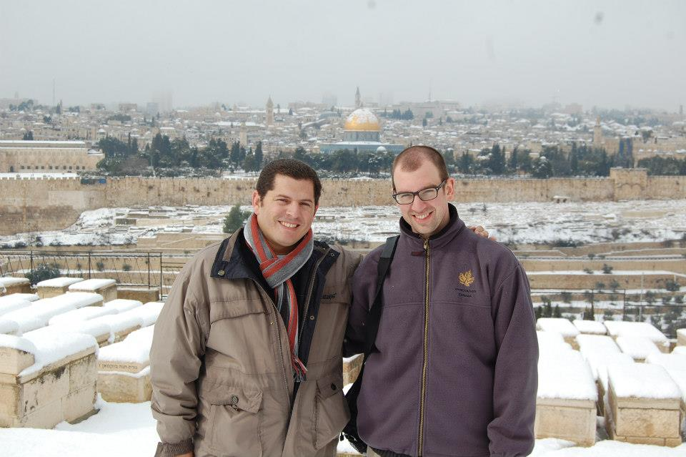

Jerusalem, Dec. 2012: It snowed in the Holy City. Deacon James Zettel with a theology companion. / Il a neigé dans la Ville Sainte.
+++++++++++++++++++++++

Le Recteur Majeur à la Famille Salésienne : Benoît XVI, un homme humble et libre
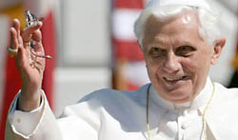
ROME : 11 FÉVRIER. (ANS). Dès qu’il a eu connaissance de l’annonce de la décision du Pape Benoît XVI de renoncer au ministère d’Évêque de Rome et de Successeur de saint Pierre, le Recteur Majeur des Salésiens a voulu adresser un message à toute la Famille Salésienne.
Bien chers Confrères, Sœurs, tous les Membres de la Famille Salésienne, Amis de Don Bosco : je vous salue avec le cœur de Don Bosco, depuis le Mexique où je me trouve pour la célébration du Jubilé d’Or de la Province de Guadalajara, ma Province d’origine.
Même si nous sommes profondément surpris de la nouvelle que nous venons de recevoir concernant la décision du Saint-Père Benoît XVI de renoncer à continuer à guider la « barque de Pierre » et à confirmer ses frères dans la foi à travers l’annonce de l’Évangile, le témoignage de sa vie, sa souffrance et sa prière, nous restons édifiés par ce geste exemplaire et prophétique.
En présentant sa démission, motivée par l’âge et la fatigue, conséquence de sa sollicitude à accompagner l’Église en une période caractérisée par de profonds et très rapides changements sociaux, qui ont à voir avec la foi et la vie chrétienne, qui réclament une grande énergie physique et spirituelle, le Saint-Père avoue avoir pris le temps du discernement devant Dieu.
Sa décision est donc le fruit de la prière et un signe exemplaire d’obéissance à Dieu ! Un tel comportement ne peut que susciter notre plus grande admiration et notre plus grande estime.
Il s’agit, encore une fois, d’un trait spirituel typiquement sien : l’humilité qui le rend libre devant Dieu et devant les hommes, et met clairement en évidence son sens des responsabilités.
Tout en exprimant au Saint-Père, comme l’aurait fait Don Bosco, toute notre gratitude pour la générosité avec laquelle il a servi l’Église et s’est montré si paternel à l’égard de notre Famille, nous l’accompagnons dans cette nouvelle phase de sa vie de notre grande affection et de notre prière.
Dès à présent, prions pour l’Église, en invoquant l’Esprit Saint afin que ce soit Lui à guider la fin de ce pontificat et la célébration du prochain Conclave.
Confions à Marie Immaculée Auxiliatrice, en cette fête de Notre-Dame de Lourdes, le Saint-Père et toute l’Église. Elle continuera à se manifester, comme toujours au long de l’histoire, Mère et Maîtresse.
De tout cœur et en union de prière.
Don Pascual Chávez V., SDB
Recteur Majeur
++++++++++++++++
Rector Major’s Message: thank you, Holy Father
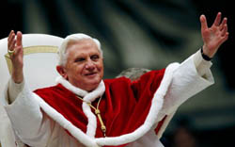
ROME (ANS – Feb. 28). As soon as Benedict XVI reached Castelgandolfo yesterday evening, the Rector Major, Fr Pascual Chavez Villanueva, prepared a message to the Congregation and the Salesian Family. Here below the full text.
My dear brothers and sisters, members of the entire Salesian Family, Friends of Don Bosco
Today the See of Peter is vacant due to Pope Benedict XVI's resignation from exercising the Petrine Ministry entrusted to him eight years ago.
We, Don Bosco's Family throughout the world, are deeply grateful for the courageous act of service carried out by our beloved Holy Father, and we accompany him sincerely in sympathy and with devotion, as he himself has asked us to do, through our constant prayer.
Pope Benedict XVI, who has offered many gestures of kindness and affection for our Family, has been a true gift of God to his Church and the world today. In his farewell address he said he had never felt alone, not even at times when it seemed as if God was asleep. We want to re-assure him that he will never be alone, because his splendid magisterium and his imposing figure will remain in our hearts. History will reveal his great humanity, intellectual vigour, his deep spiritual life, his total love for Christ and his magnificent service to the Church and the world.
God's Church has not been left orphaned. The Lord Jesus, her Head, and the Spirit of God, the Paraclete, constantly presides over her and guides her.
I ask you to join me in heartfelt prayer, along with Mary who shared her life and prayer with the Apostles, while we wait in trust and serenity for God to give us a new Pastor according to his heart.
Let the conversion to which the Word of God calls us during Lent be our best way of imploring this grace.
With affection and promise of a memento at Mass
Rome, 28 February 2013
Fr Pascual Chávez V., SDB
Rector Major
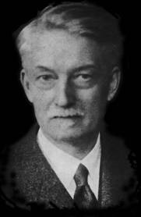
==========================

JACQUES MARITAIN (1882-1973)

« La nouvelle mission de l'homme de Dieu Benoît XVI »

Parallèle éclairant avec Jacques Maritain
Mgr Bruno Forte
ROME, 6 mars 2013 (Zenit.org) - Le choix de Benoît XVI de se retirer dans le silence et la prière est comparable à la décision de Jacques Maritain de se retirer de tout engagement public pour vivre jusqu’à sa mort une vie de contemplation, estime Mgr Bruno Forte, archevêque de Chieti-Vasco en Italie. Mais de quel silence s’agit-il et pourquoi ?
Ci-dessous sa réponse dans un éditorial publié le 1er mars dernier sur le quotidien italien « Il Sole 24 Ore », au lendemain du départ de Benoît XVI :
« La nouvelle mission de l’homme de Dieu Benoît XVI »
« L’Église catholique a un pape émérite. Depuis le 28 février au soir le Siège de Pierre est vacant et Benoît XVI a commencé sa nouvelle vie d’ouvrier de la vigne du Seigneur dans le silence de la prière et caché au monde.
On a beaucoup écrit sur le sens de sa renonciation. Pour moi, le sens qui mérite d’être développé est celui de sa nouvelle mission, cette autre mission comme l’ont laissé encore entendre ses paroles lors de sa dernière audience générale : « Je n’abandonne pas la croix mais je reste d’une façon nouvelle près du Seigneur crucifié. Je n’assume plus le pouvoir de la charge du gouvernement de l’Église, mais je demeure dans le service de la prière, pour ainsi dire, dans l’enclos de Saint-Pierre ».
Pour comprendre la force de ces paroles, je recours à une analogie qui me paraît particulièrement claire: celle entre le choix du pape Benoît et la décision que le grand penseur catholique Jacques Maritain a pris après la mort de son épouse bien-aimée Raïssa, avec qui il avait entrepris son chemin de conversion au Christ et avait vécu une expérience spirituelle mystique sous tant d’aspects.
Celui-ci avait voulu se retirer de tout engagement public pour vivre jusqu’à sa mort une vie de contemplation auprès des Petits Frères de Jésus de Toulouse, poussé par un désir confessé en ces termes: « J’ai un grand besoin de silence ». De quel silence s’agissait-il ? Jacques Maritain l’explique lui-même par ces mots: « On n’accepte pas la Croix, on la prend, on adore la Croix ».
Le silence du vieux philosophe français n’est pas diffèrent de celui du pape allemand : il s’agit du silence de l’écoute et de l’adoration, rester seul avec le Christ uniquement, non pas pour fuir le monde, mais pour se transfigurer et le transfigurer en Lui sur les chemins mystérieux que seul la Grâce connaît.
L’épouse de Maritain, Raïssa, dont le Journal témoigne d’une vie mystique très pure, laisse entendre quelque chose de ce silence, habité par Dieu et vécu en Dieu, dans une de ses plus belles poésies, Transfiguration: « Quand… j’aurai conquis ma liberté céleste / …et que j’aurai choisi le chemin le plus dur / comme le ciel nocturne illimité et pur … / comme un navire fortuné / qui s’en revient au port sa cargaison intacte / j’aborderai le ciel le cœur transfiguré / portant des offrandes humaines et sans tache ».
A côté de cette recherche de silence, un silence mystique, il y a dans cette nouvelle vie de Benoît une volonté évidente de service, une intention profonde d’amour de l’Église et du monde. Sur cet aspect aussi l’analogie avec Jacques Maritain nous aide à en comprendre les raisons. Voici comment il décrit la tâche des contemplatifs, témoins de l’absolu de Dieu dans ce monde:
« En cette nouvelle heure que nous venons de franchir nous voyons se révéler – tant dans la matière et grâce aux découvertes de la métaphysique, que dans les activités humaines et grâce aux explorations de l’inconscient - un certain primat de l’invisible sur le visible et du non manifesté sur le manifesté. C’est ici qu’apparaît, à mon avis, le rôle prophétique … affirmer dans l’existence la valeur première du témoignage rendu à l’amour de Jésus pour les hommes, non pas par des grands moyens visibles, mais de la façon invisible ou presque invisible de la simple présence d’amour fraternel … De quoi les hommes ont-ils besoin avant tout ? Ils ont besoin d’être aimés ; d’être reconnus ; d’être traités comme des êtres humains ; de sentir que toutes les valeurs que chacun porte en soi sont respectées. C’est pourquoi il ne suffit pas de leur dire ‘je vous aime’. Tout comme il ne suffit pas de leur faire du bien. Il faut exister avec eux, dans le sens le plus profond de cette expression ».
Voilà quelle est la signification de la nouvelle mission de l’homme de Dieu Benoît XVI, pape émérite: partager la condition de beaucoup - d’innombrables - vies cachées aux yeux du monde, mais pas à ceux de Dieu, pour dire à chaque existence humaine combien elle est aimée par le Seigneur et combien elle a du prix à ses yeux. Et ainsi aider précisément la cause de l’homme dans ce monde, la dignité de chaque personne humaine dans l’horizon de l’éternité et en reconnaissant – en même temps que ses fragilités immanquables – sa grandeur immortelle.
Cette cause est aussi celle de Dieu, à l’image duquel l’homme est créé. Elle est celle pour laquelle l’Église existe et au service de laquelle elle continue à œuvrer, confiante et sereine, parmi les lames du temps, soutenue par les racines cachées et profondes de tant d’ouvriers humbles et silencieux de la vigne du Seigneur. Parmi eux, le Pontife émérite. »
+++++++++++++++++++++++++++
JOYEUSES PÂQUES !
A BLESSED EASTER !

