
SOCIETA’ DI SAN FRANCESCO DI SALES
sede centrale salesiana
Via Marsala 42 - 00185 Roma
Consigliere generale per la formazione
icoelho@sdb.org

Rome, 13 May 2018
Feast of the Ascension of Our Lord
Prot. 18/0202

To:
Provincials
Provincial Formation Delegates

13 May 2018

Subject: Study seminar on Salesian meditation, San Callisto – Rome, 10-12 May 2018

Dear confreres,

Greetings to you from Rome, where we have just concluded a small study seminar on Salesian meditation. The participants were Jose Kuttianimattathil INK (coordinator), Xavier Blanco SSM, Giuseppe Buccellato ISI, Eunan McDonnell IRL, Cleofas Murguia, Giuseppe Roggia UPS, Gianni Rolandi from the Missions Department, and Silvio Roggia, Francisco Santos Montero and myself from the Formation Department. The aim was to clarify the place of meditation in the Salesian tradition and life and to offer guidelines for growth in this area. I offer you this rather long letter as a way of sharing the fruits of our seminar.

The seminar originated in a suggestion by Xavier Blanco, Rector of the Salesian house in Santiago de Compostela, Spain, where we were meeting for the last “Consulta” on Formation (February 2016). During a mass at which he was presiding, Xavier surprised us by saying: “Why don't you teach us to meditate?” In the light of the fact that we are in the process of revising the manual of Salesian prayer at the request of GC27, we thought that a seminar dedicated to this theme would be more than opportune. The participants, we eventually decided, would be the formation team led by Jose Kuttianimattathil, Eunan McDonnell, Giuseppe Buccellato and Giuseppe M. Roggia for their expertise in Salesian matters, and Xavier Blanco himself.

The seminar was hosted by the San Callisto community in the wonderfully peaceful setting of the catacombs of San Callisto, 10-12 May 2018. We began with a sharing of our personal experiences in meditation: our initiation to meditation, how we meditate, what impact meditation has on our life and apostolate, what difficulties we encounter.

The next step involved illuminating our experience with the Salesian tradition. Drawing upon his experience of forming and guiding generations of young Salesians, Giuseppe M. Roggia shared what he considered important elements in formation to meditation. Giuseppe Buccellato offered us amazing information about the role of mental prayer in the founding charism of Don Bosco, and how Don Giulio Barberis, the first novice master, dedicated the first two months of the novitiate to formation to meditation. Eunan McDonnell drew upon Francis de Sales and his own experience to present first why we should meditate, and then some elements of the how. Xavier Blanco held up Jesus as the man of the “three times” in whom action, prayer and community come together in a wonderful way, before drawing upon the new thirst for silence and meditation that is manifesting itself in Spain, for example through the work of Pablo d’Ors.

After a time of silence to allow things to sink in, facilitated by a guided meditative visit to the catacombs, there followed a moment of diagnosis and brainstorming: how is it that so many of us lose interest in meditation, even while in initial formation? Is there a specific Salesian method of meditation? Are there other methods that might be in harmony with our spirituality? What could we learn about meditation from the study of Salesian Personal Accompaniment conducted by the departments of Youth Ministry and Formation? What could be done to reawaken esteem and love for meditation among Salesians in initial and ongoing formation? What might be the steps for an efficacious initiation to Salesian meditation? How might Salesian meditation be related to other types of meditation such as the lectio divina, centering prayer and the Jesus prayer?

The final step was an effort to gather the fruits of the two days of study, prayer and reflection, and to see how to share them with the congregation. I put them down here by way of sharing, hoping that you will find something of use.

Preambles:
- If we are convinced about the value and place of meditation in our lives, we will be certainly more inclined to be faithful to meditation and to learn how to grow in it.
- Praying together is linked to working together, and is therefore a charismatic element for us.
- At the present moment, many have little or no training to meditation. This is part of the general weakness of the pedagogical dimension of our formation
- In the initiation to prayer, we cannot presume that people have a relationship with God. If this fundamental presupposition is missing, we risk building without a foundation.
- If there is ‘fear’ in the phases of initial formation, meditation tends to become a formality rather than a conviction.

Meditation in the founding charism of Don Bosco:
- It has been amazing to see how much Don Bosco and the first generation insisted on meditation: see the additions to the Italian edition of the Constitutions, the attention given by Barberis to teaching novices the why and how of meditation, and the insistence of Rinaldi.
- A good knowledge about our origins helps us see the importance and place of meditation in our charism.
- Given the fact that the principal inspirations of the Convitto Ecclesiastico were Ignatian and Liguorian, and given that Don Bosco continued making the Spiritual Exercises at Sant’Ignazio sopra Lanzo up to 1874, we could say that he learned the Ignatian method of meditation. Given that Francis de Sales himself draws upon Ignatius, however, we have a consonance of methods.

Why to meditate:
- First of all, in imitation of the one who has loved us and whom we love: in Jesus we see the unity of action, prayer and community.
- Without mental prayer, our relationship with God cannot deepen.

How to meditate:
- Some method is needed, at least in the beginning
- There is no one method of Salesian meditation, though meditation is certainly something distinct from spiritual reading (as we see clearly in Don Bosco’s life and writings). But some of what we say below will set the parameters and indicate some preferences.
- Method consists first of the right dispositions of the heart: faith, fidelity, trust and perseverance
- Perseverance is of the utmost importance, and is a word that occurs often on the lips of Jesus and in the New Testament. We learn to pray by praying, and it is important to ‘be there,’ day by day, for meditation.
- Moments of intense prayer (such as the Spiritual Retreat) and personal spiritual accompaniment can create a good foundation for meditation.
- Preparation, both remote and proximate, is of the utmost importance: the habit of reading the Word of God, the Constitutions and good spiritual reading, and the reading of the Word and perhaps a comment the previous day.
- The Word of God and the Constitutions are privileged texts for our meditation.
- Christ is at the centre of Christian meditation. He is, as Teresa of Avila and Francis de Sales insist, the door through which we enter; it is he who will lead us, if and when he wants, to wordless, affective, contemplative prayer.
- The word meditation comes from ‘giving care to,’ ‘giving attention to.’ We begin meditation by placing ourselves in the presence of God, giving attention to him who is always there and who desires to communicate with us.
- In the novitiate, it might be good to concentrate on a single method, such as that of the lectio divina.
- Collatio or sharing presupposes that one has already done lectio and meditatio, that one has been touched by the Word; otherwise, what is there to share?
- Keeping a journal is also useful, in order to see the direction in which God is leading me.
- A good meditation echoes through the day, gradually overcoming the ‘parallelism’ in our life and leading us to unification of our practices of piety, the sacraments, life and work.
- The fruits of meditation are seen in the transformation that takes place in life.
- Salesian spiritual guides need to ask about prayer and meditation, and should learn how to accompany confreres in this area.

Among the steps we want to take in the immediate future are the following:

- An e-book of the material from the seminar, to be shared with all the confreres
- A note on some methods of Salesian meditation to be inserted into the new manual of prayer, along with other material, at www.sdb.org/
- Animation of the provincial formation delegates during the various meetings of the Regional Formation Commissions 2018.
- Preparation of didactic material on meditation with the help of novice directors and those in charge of prenovices
- Formation of formation guides in the area of meditation
- Involving the various regional centres of ongoing formation by means of courses and other initiatives
- Making meditation and prayer a theme in the work of GC28, given that the quality of evangelization is directly related to the quality of our prayer and meditation.

From the seminar itself we have learned that it is very fruitful, especially in the area of something like meditation, to begin by attending to our personal experience and by sharing it with simplicity, before illuminating it with the tradition. We also realized that the dynamics of a small group are quite different from that of a larger one. This method itself might be something precious in our effort to make progress in meditation, given that it exemplifies the “learning by experience” that is at the core of C 98: “Enlightened by the person of Christ and by his Gospel, lived according to Don Bosco’s spirit, the Salesian… learns by experience the meaning of the Salesian vocation….”

I end with a feeling of quiet gratitude in my heart for this little seminar that arose from the spontaneous request of a confrere. I would like to thank all the confreres who participated and made their contributions in a spirit of great simplicity, to Jose Kuttianimattathil and Silvio Roggia for their coordination and animation of the seminar, to Gianni Rolandi who so willingly joined us to help with translations, and the community of San Callisto that hosted us with such warmth and fraternity. One seminar, we might ask, what difference will that make? At least it made a difference to us who participated, I must say; and then, as Don Bosco said, if we accompany our work with prayer, two grains that are sown will give us four.

A happy feast of the Ascension of our Lord, the feast of Jesus “seated at the right hand of God” and at the same time “acting with us” in our proclamation of the Word and in the signs that accompany it (Mk 16,19-20), most especially the signs of our transformed lives. May our Lady of Fatima and Mary Mazzarello, with their spirit of contemplation, intercede for us!

Affectionately,
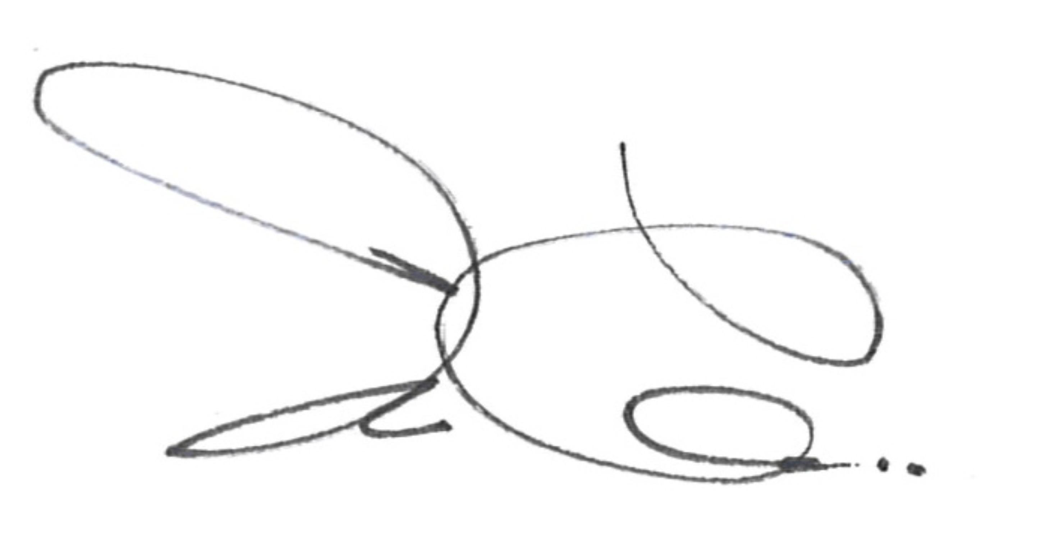
Ivo Coelho, SDB

See “Lettera di S. Vicenzo de’ Paoli indirizzata a’ suoi religiosi sul levarsi tutti all’ora medesima (15 gennaio 1650)” annessa alle Costituzioni della Società di S. Francesco di Sales dal 1877 al 1907; G. Barberis, Manoscritto Barberis del 1875 dal quaderno delle istruzioni ai novizi, Archivio Centrale Salesiano; G. Barberis, Il vade mecum dei giovani salesiani, nuova edizione riveduta e corretta (Torino, 1931), ch. 12: Della meditazione; G. Buccellato, Alla presenza di Dio. Ruolo dell’orazione mentale nel carisma di fondazione di San Giovanni Bosco, Tesi Gregoriana, Serie Spiritualità 9 (Roma: Editrice Pontificia Gregoriana, 2004); G. Buccellato, Don Bosco, Sant’Ignazio e la Compagnia di Gesù: storia di una relazione nascosta… ma non troppo, in id., Alle radici della spiritualità di San Giovanni Bosco (Città del Vaticano: Libreria Editrice Vaticana, 2013); G. Buccellato, “Giovanni Bosco: il geloso custode della sua vita con Dio,” Nuovo Dizionario di Mistica, ed. L. Borriello, E. Caruana, M. R. del Genio and R. Di Muro (Città del Vaticano: Libreria Editrice Vaticana, 2016); G. Buccellato, Da due grani nasceranno quattro spighe. Piccola antologia di insegnamenti di San Giovanni Bosco sulla preghiera (Torino: ElleDiCi, 2017).
See Pablo d’Ors, Biografía del silenzio (Siruela, 2015)
See Marco Bay, Giovani salesiani e accompagnamento: Risultati di una ricerca internazionale (Roma: LAS, 2018).
A note from Rinaldi found by Giuseppe Roggia in the novitiate house of Pinerolo: “Are the novices learning to meditate? It is the most important thing.”

